

|  |  |  |
| --- | --- | --- |
| **Module Code** | **:** | CT106-3-2-SNA –Systems and Network Administration |
| **Intake Code** | **:** | APU2F2502CS(CYB) |
| **Lecturer Name** | **:** | Shahab Alizadeh |
| **Hand in Date** | **:** | Week-10 |
| **Hand out Date** | **:** | Week-3 |
| **Title** | **:** | Individual SNA Network Administrator Project |

|  |  |
| --- | --- |
| **Student ID** | **Student Name** |
| TP080254 | Er Chen Liang |

**Table of Contents**

1.0 Introduction 3

2.0 Email Server Configuration of Postfix 4

3.0 Installation and Configuration of Dovecot 14

4.0 Installation and Configuration of Thunderbird in Rocky Server 22

4.1 Installation and Configuration of Thunderbird in Ubuntu Client 24

**4.1.1 Problem Occurred 28**

5.0 SSL/TLS Implementation 33

**5.0.1 Problem Occurred 40**

**5.0.2 Problem Occurred 44**

6.0 Additional (Spam Assassin) 49

7.0 Conclusion 59

8.0 Reference 59

# **1.0 Introduction**

This project is to configure and integrate the essential components such as Postfix, Dovecot, and Thunderbird Email Client. We must ensure that both of the server-side and client-side are correctly running by our configuration.

Through this assignment, we can gain the direct experience with the email protocol configuration (SMTP, POP3, IMAP) and secure practice about SSL/TLS encryption.

# **2.0 Email Server Configuration of Postfix**

**First install the Postfix in your Rocky Server:**

Install Postfix (mail transfer agent) by typing the following code in the Rocky terminal:

* sudo dnf install postfix

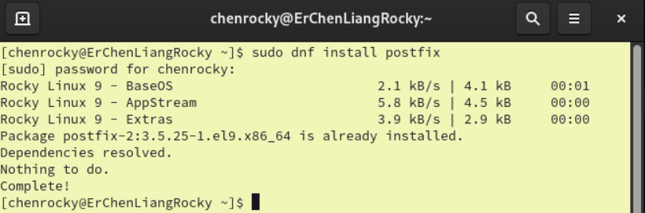



Figure

**Second find the directory configuration file:**

After the installation, we change the directory to Postfix and list the file inside to figure out where the config file of Postfix is located. And we found out the [main.cf](http://main.cf) file.

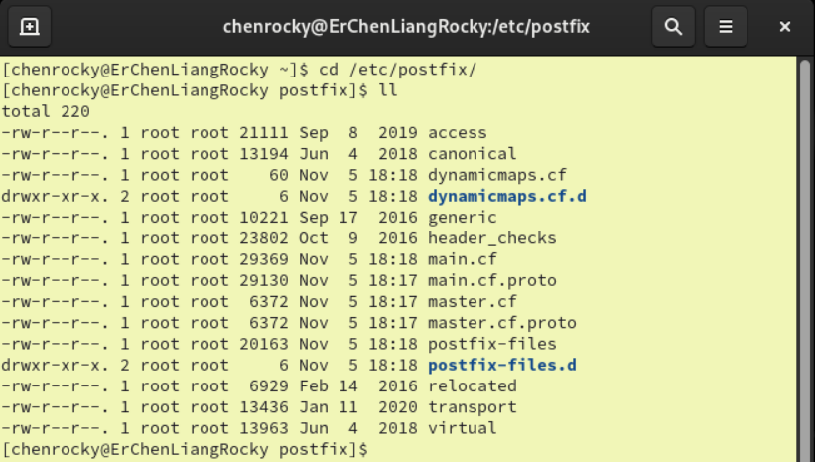



Figure

We can open it with any of text editor, here we use nano editor to open it.

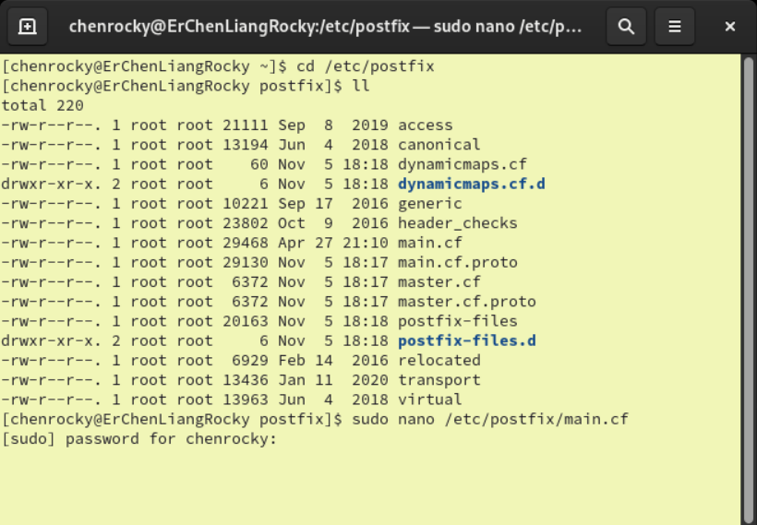



Figure

**Third configure the Postfix:**

Find the myhostname and line mydomain, then we type in our server’s hostname and domain name behind the ‘=’ symbol.

* myhostname = ErChenLiangRocky.tp080254.org
* mydomain = tp080254.org

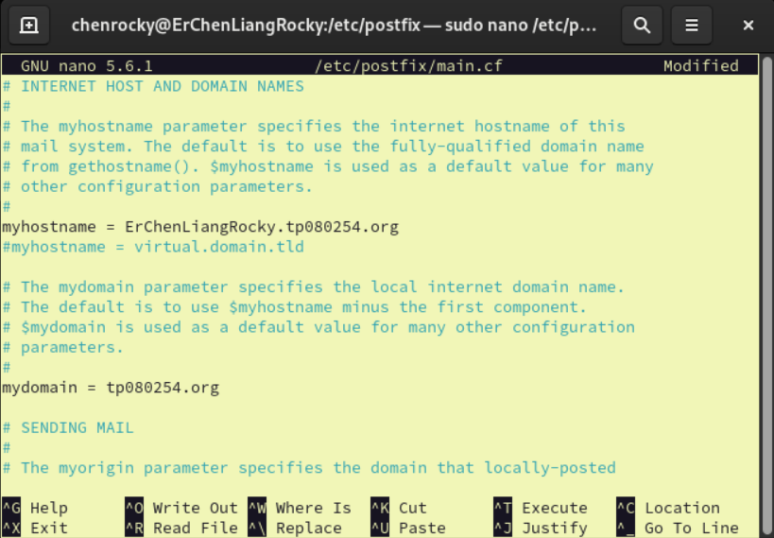



Figure

Keep scrolling down we can find the #inet_interface = all we uncomment it to help Postfix listen the incoming SMTP connections of whole network interface of server.

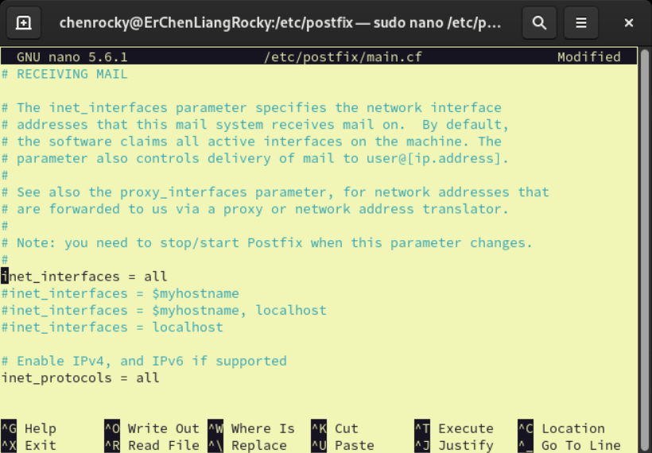



Figure

Next, is #myorigin = $myhostname and uncomment it to let the server use the hostname.

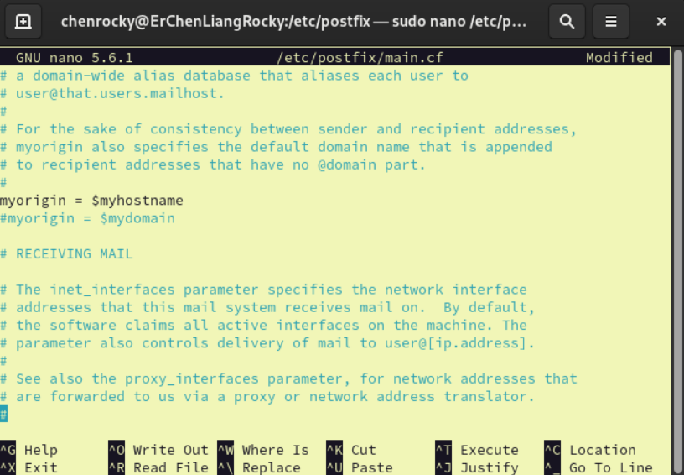



Figure

Next, is mydestination and make sure that our domain name is included in as the figure below shows.

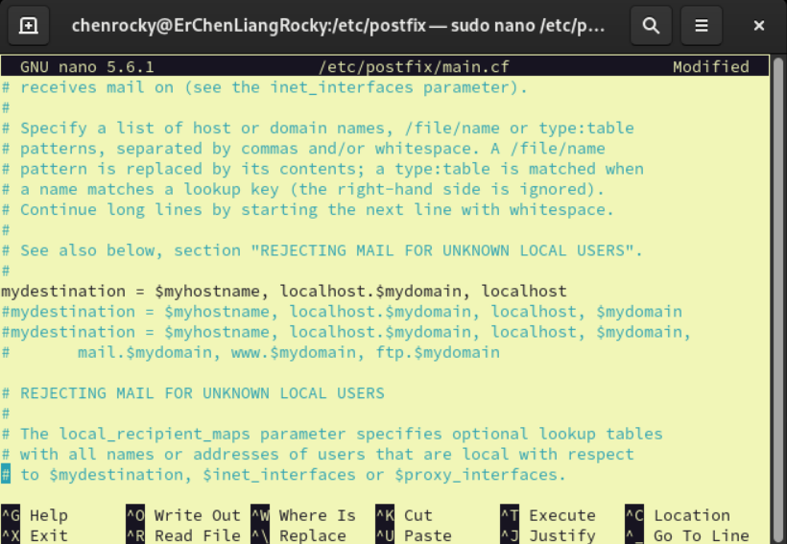



Figure

After is mynetworks we change it to our network IP.

* mynetworks = 192.168.100.0/24, 127.0.0.0/8

(Here I use 192.168.100.0 in my assignment.)

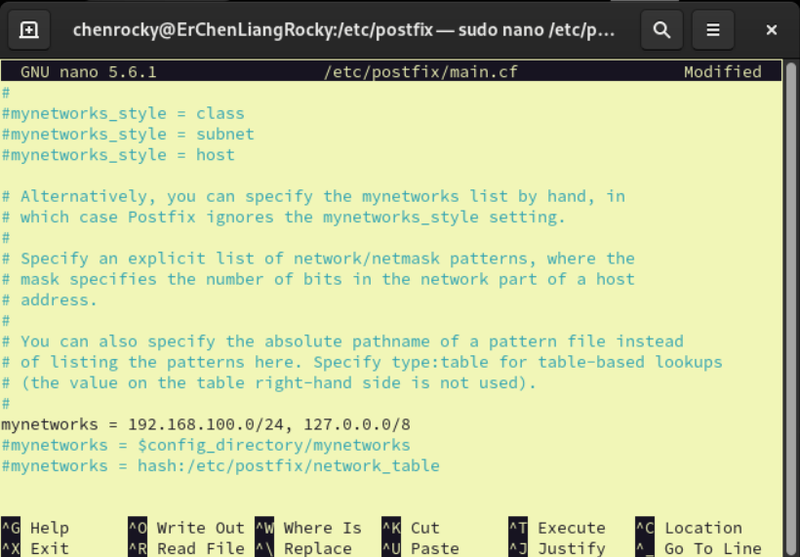



Figure 8

Next find home_mailbox and uncomment it to determines the location where the emails will be stored in the mail server.

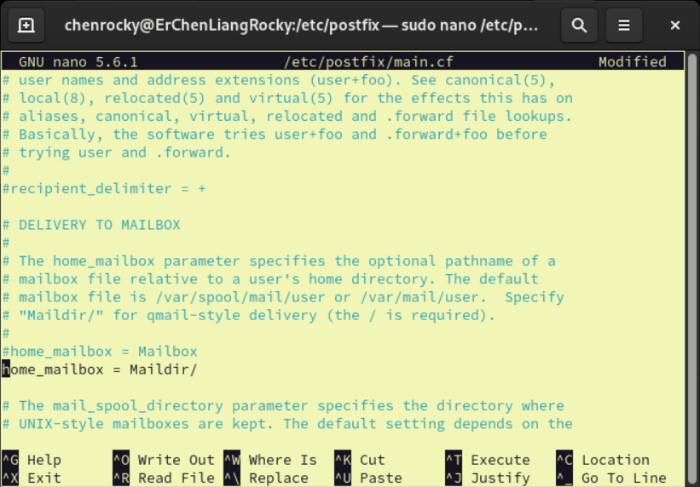



Figure 9

We don’t want to use the default TLS certificate and private key, so we uncomment these two lines.

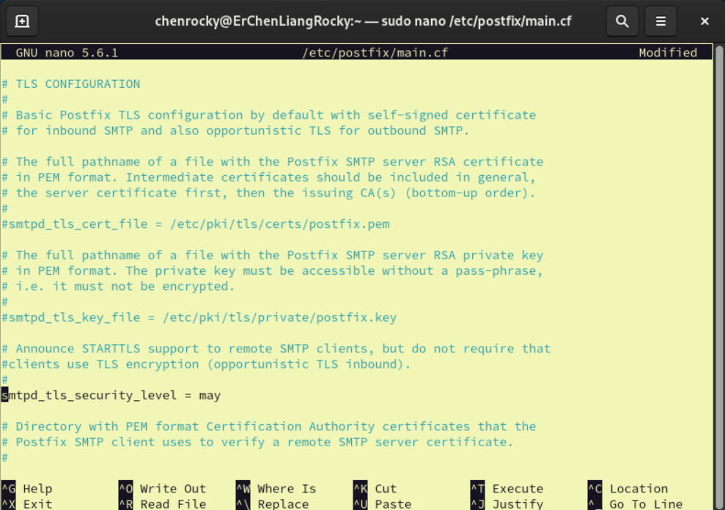



Figure 10

Then at the end of the file we add this following code in the terminal:

* Smtpd_helo_restrictions = permit_mynetworks, reject_unknown_hostname, reject_non_fqdn_hostname, reject_invalid_hostname, permit

**Explanation:**

* Permit_mynetworks: which can allow the clients from trusted networks that we set at the mynetworks.
* reject_unknown_hostname, reject_non_fqdn_hostname, reject_invalid_hostname: It will reject the HELO command if the hostname cannot be recognised to an IP address or if it is not a fully qualified domain name and which contains invalid characters.
* Permit: permit all of the client that pass the requirement.

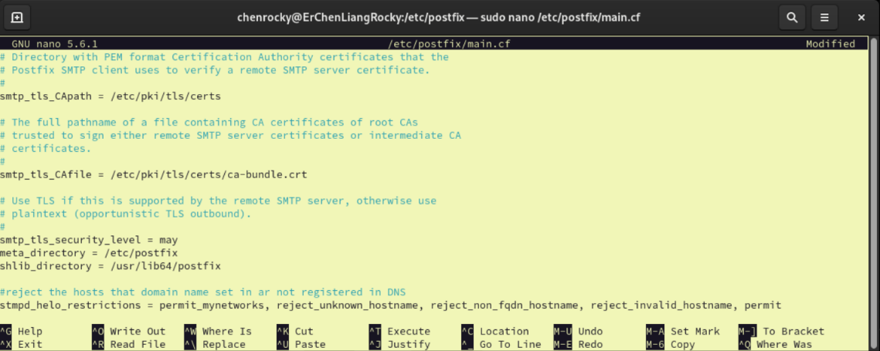



Figure 11

Then save and close the nano.

**Fourth start the Postfix and check its status by the following code in the terminal:**

* sudo systemctl enable postfix
* sudo systemctl start postfix
* sudo systemctl status postfix

(We can see that the Postfix service is perfectly running without any error)

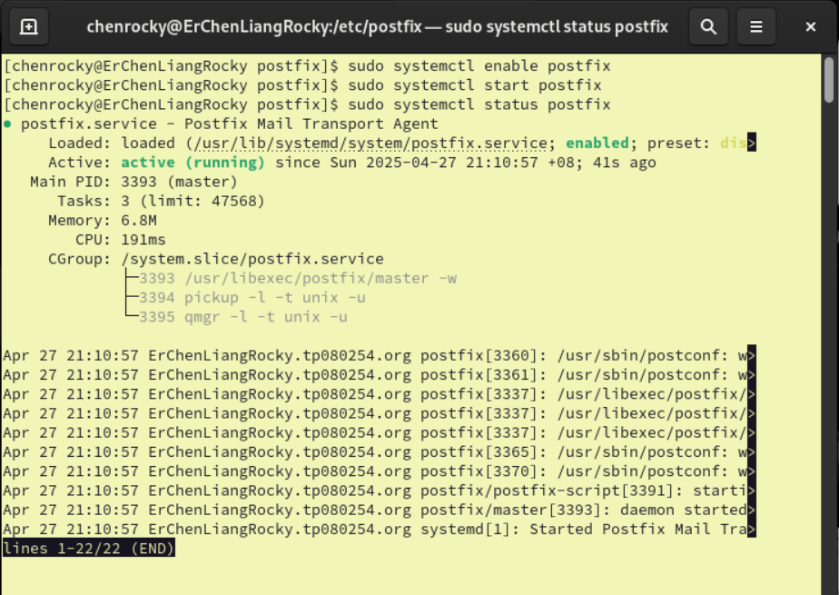



Figure 12

Verify the Postfix service is running or not.

* telnet ErChenLiangRocky.tp080254.org 25

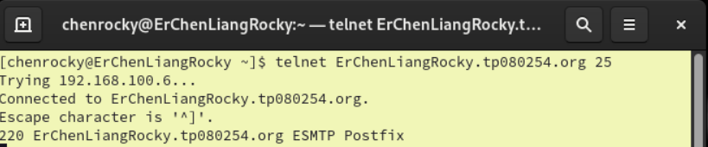



Figure 13

If success we will see ESMTP Postfix as Figure 13.

# **3.0 Installation and Configuration of Dovecot**

**Frist install Dovecot:**

Install Dovecot by typing the following command in the Rocky Terminal:

* sudo dnf install dovecot

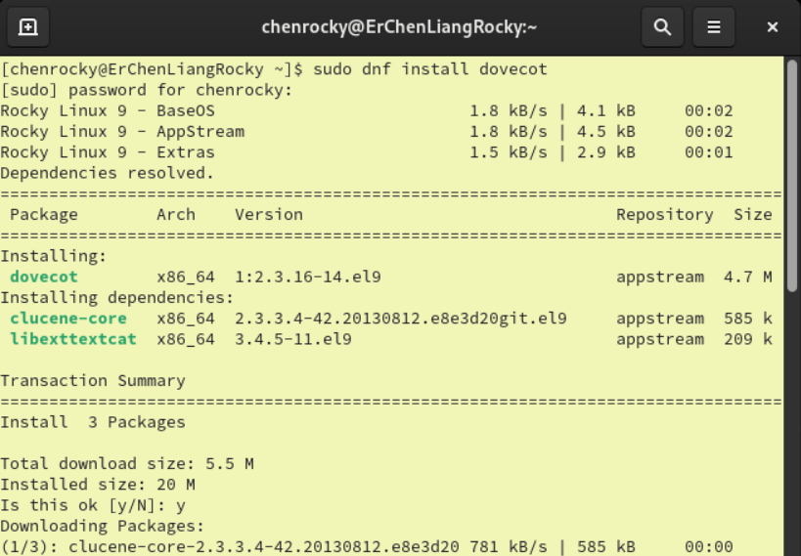



Figure 14

**Second configure the Dovecot:**

Start the Dovecot and check its status by following command:

* sudo systemctl start dovecot
* sudo systemctl enable dovecot
* sudo systemctl status dovecot

(as we can see the Dovecot is running perfectly without any error)

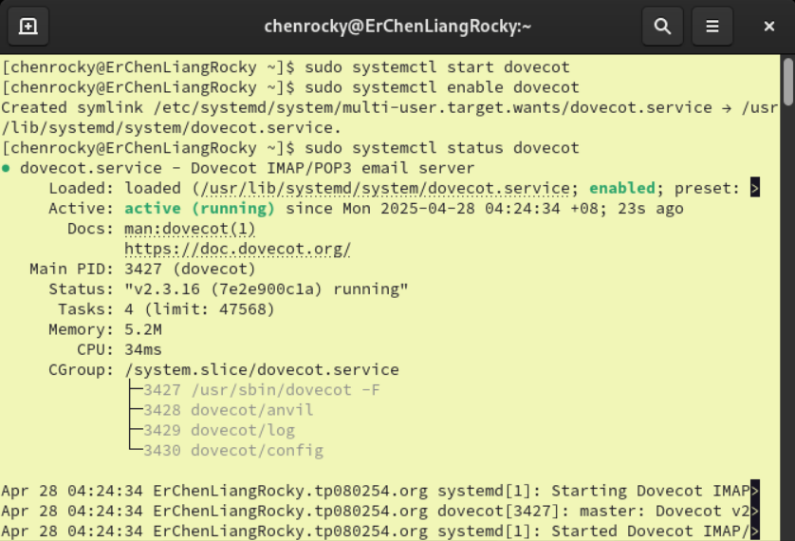



Figure 15

we change the directory to Dovecot and list the file inside to figure out where the config file of Dovecot is located. And we found out the [dovecot.conf](http://main.cf) file.

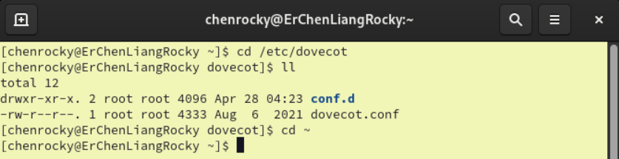



Figure 16

When we found out the configuration file, we edit it with the nano editor:

* sudo nano /etc/dovecot/dovecot.conf

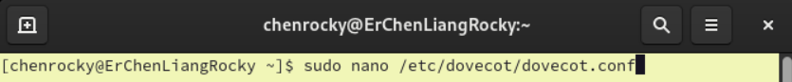



Figure 17

Find #protocols = imap pop3 lmtp submission and #listen =*, :: and uncomment them.

* protocols = imap pop3 lmtp submission: allow you to specify protocols that you would like to use. Right here, LMTP is the best choice for this situation.
* listen =*, ::: allow to set the IP address where you want the dovecot to listen to.

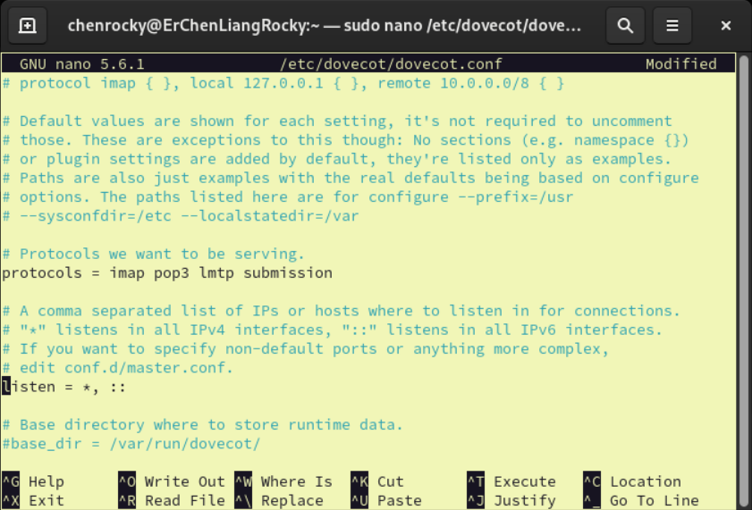



Figure 18

Then save and close the nano.

Configure the location of the mailbox file:

* sudo nano /etc/dovecot/conf.d/10-mail.conf

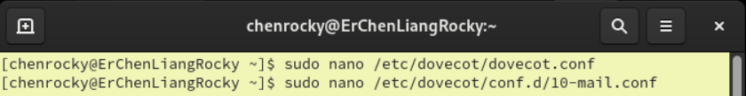



Figure 19

Find the commented #mail_location = maildir:~/Maildir and uncomment it:

* mail_location = maildir:~/Maildir: to tells Dovecot where to find or store the user’s email.

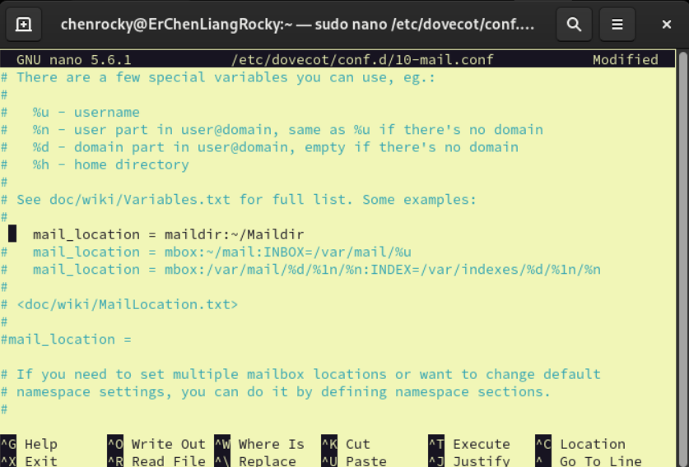



Figure 20

Then save and close the nano.

Next, edit the Dovecot auth configuration file:

* sudo nano /etc/ dovecot/conf.d/10-auth.conf

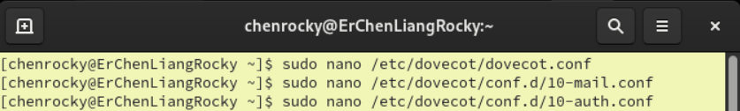



Figure 21

Find the commented #disable_plaintext_auth = no and uncomment it:

* disable_plaintext_auth = no: allow user to log in using plain-text username and password.

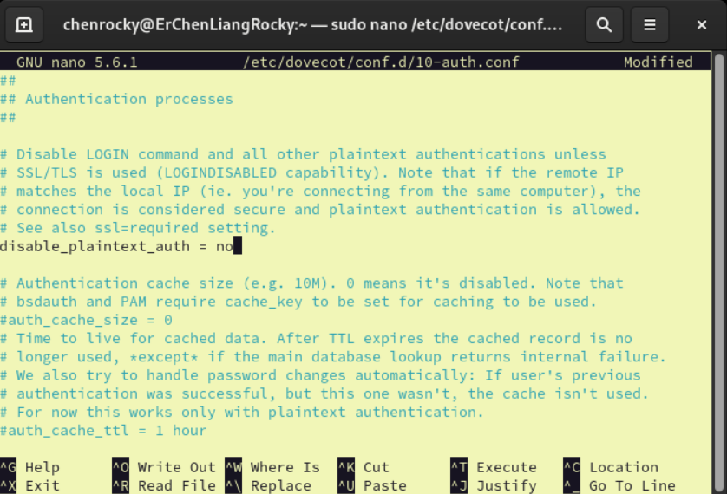



Figure 22

Next, edit the following line:

* auth_mechanisms = plain login: enable Dovecot to support PLAIN and LOGIN authentication methods.

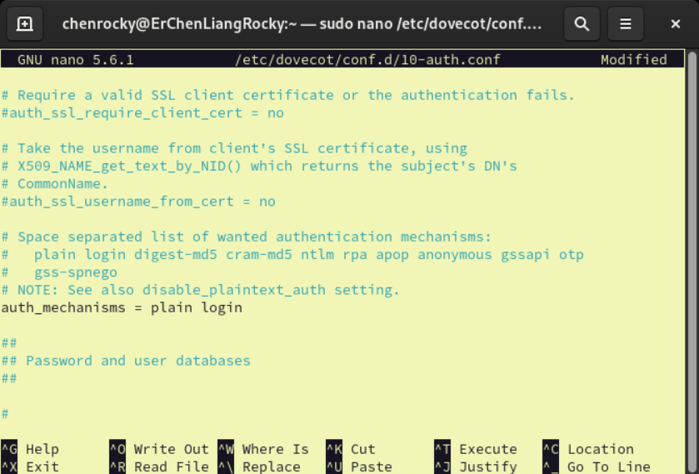



Figure 23

Last, edit the Dovecot master configuration file:

* sudo nano /etc/dovecot/conf.d/10-master.conf

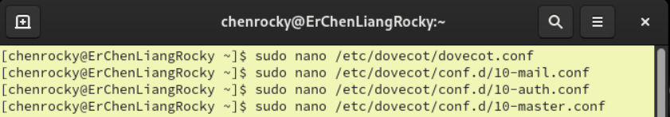



Figure 24

Find the #Postfix smtp-auth:

* We edit the ownership of user and group to postfix

Then save and close the nano.

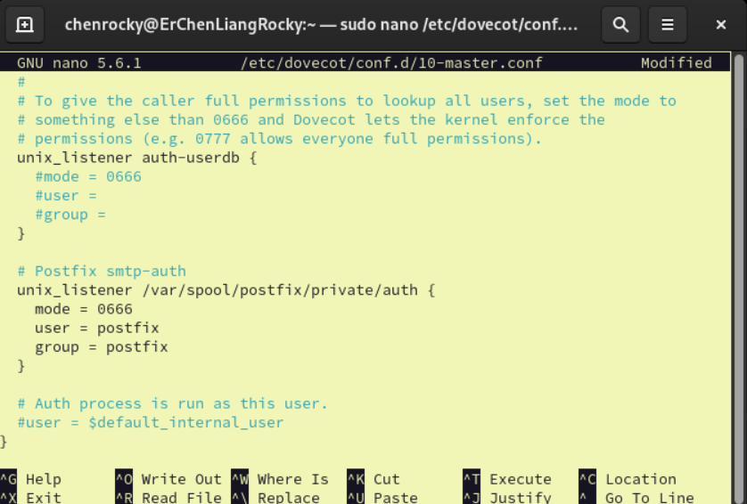



Figure 25

Then we restart the Postfix and Dovecot.

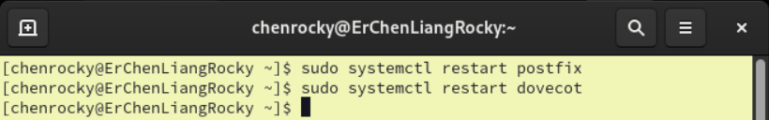



Figure 26

Verify the Dovecot service try connection the port 110 with telnet.

* telnet ErChenLiangRocky.tp080254.org 110

After entering the username and password, we can see the “Logged in” popped out which means the dovecot is running successfully.

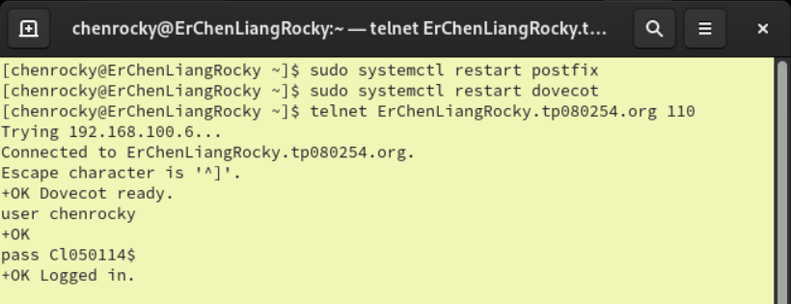



Figure 27

# **4.0 Installation and Configuration of Thunderbird in Rocky Server**

**Step 1: Install Thunderbird (Mail Server)**

Install Thunderbird by typing the following command:

* sudo dnf install thunderbird

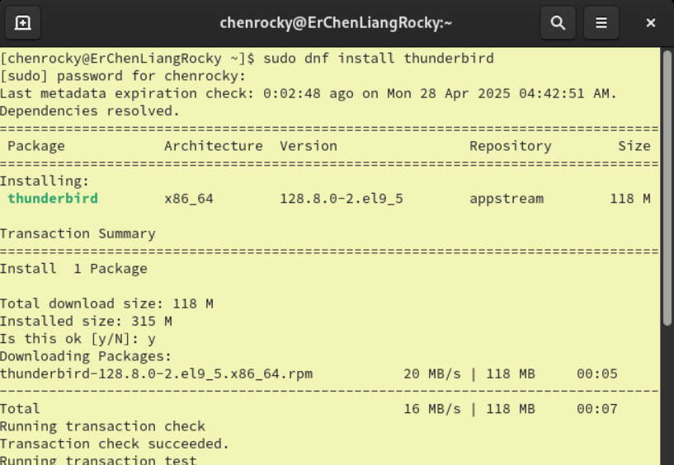



Figure 28

After we completed the installation of “Thunderbird”, we have to enable the SMTP port and IMAP ports in firewall security system.

**Why should enabling the SMTP port and IMAP ports:**

* **Simple Mail Transfer Protocol (SMTP):** This protocol can allow us to send emails from your Virtual Box to the external servers. After we enable the port 25, the Thunderbird will be able to send the emails.
* **Internet Message Access Protocol (IMAP):** This protocol allows your email client to retrieve and manage messages stored on the mail server. After we enable the port 110, the Thunderbird will be able to download the emails.

Then we use the command to reload:

* sudo firewall-cmd --reload

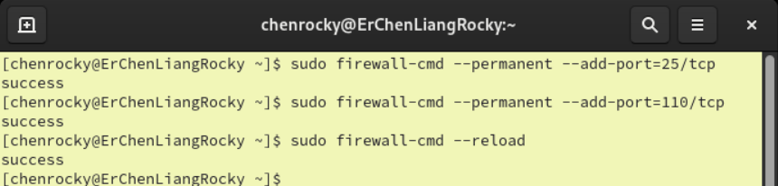



Figure 29

# **4.1 Installation and Configuration of Thunderbird in Ubuntu Client**

**Step 1: Install Thunderbird at the Ubuntu App Center**

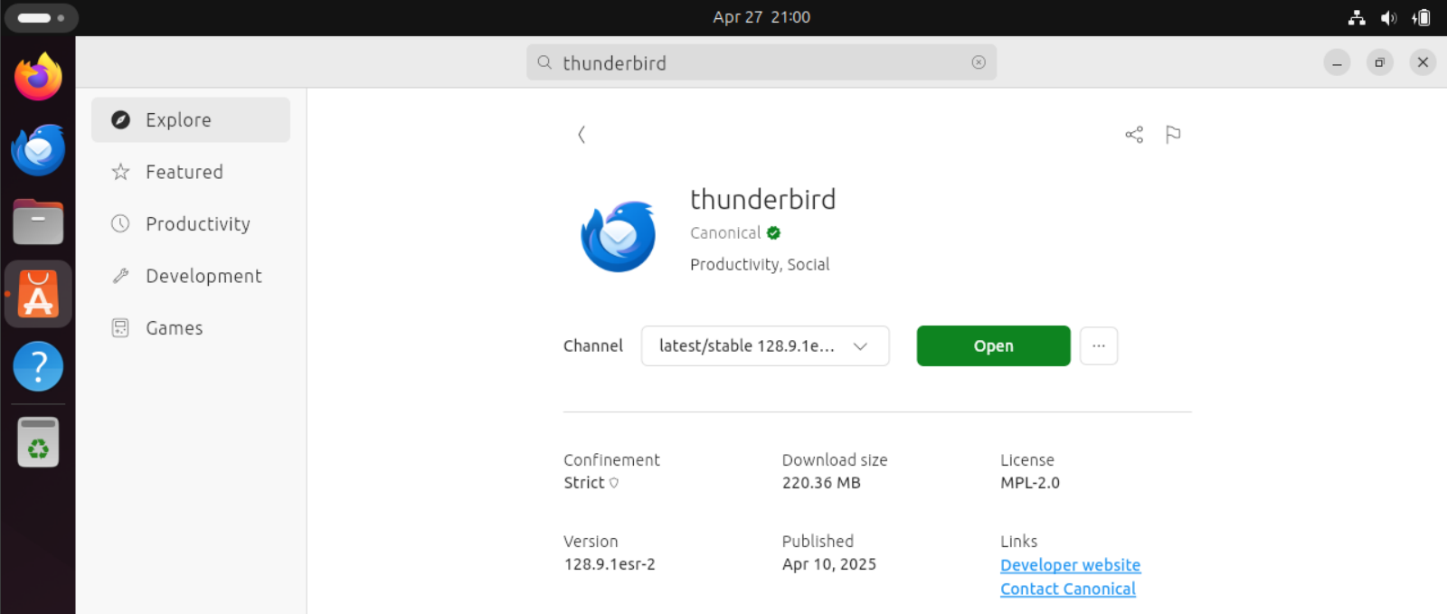



Figure 30

**Step 2: Fill in the following details to setup an account in Thunderbird.**

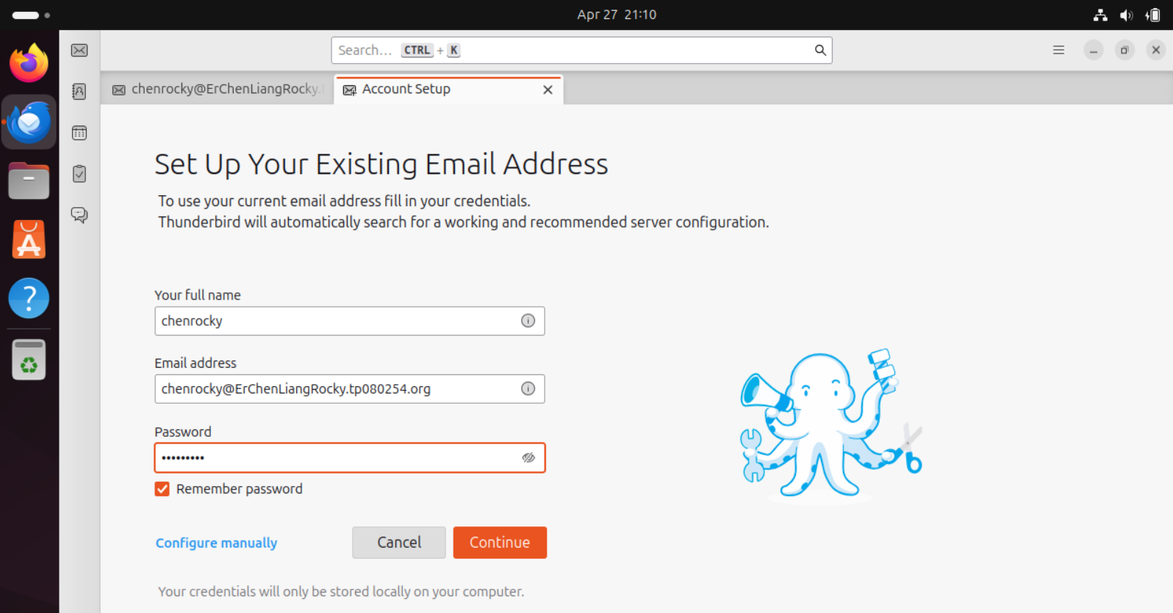



Figure 31

* We can see that the configuration of the server is automatically detected, so we just need to click on the Done button.

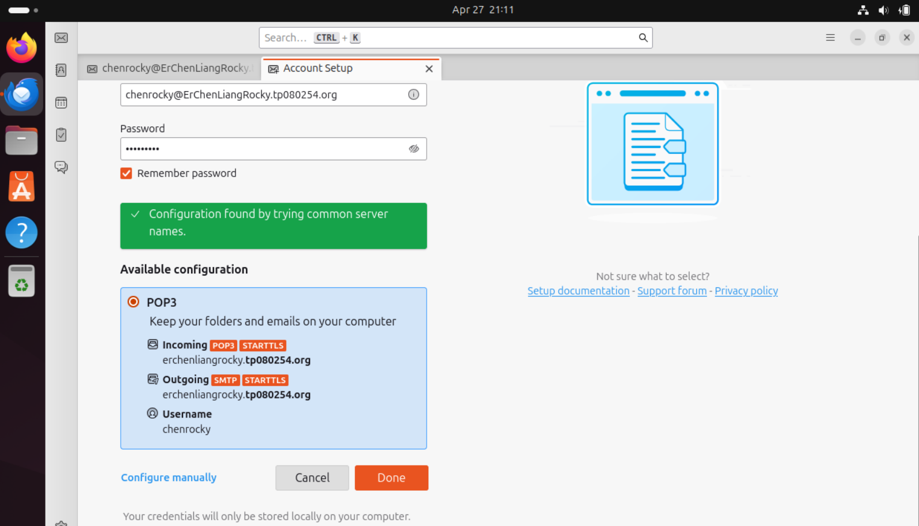



Figure 32

* After we click the Done button, a message box will appear and we just need to click on the lower left button which is Confirm Security Exception.

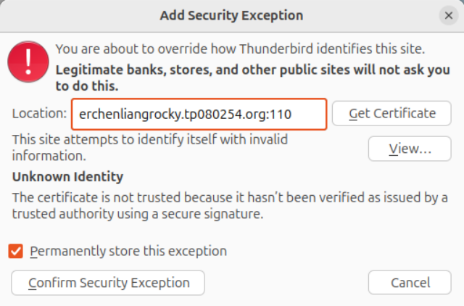



Figure 33

* If the account created successfully, it would show a page like Figure 36.

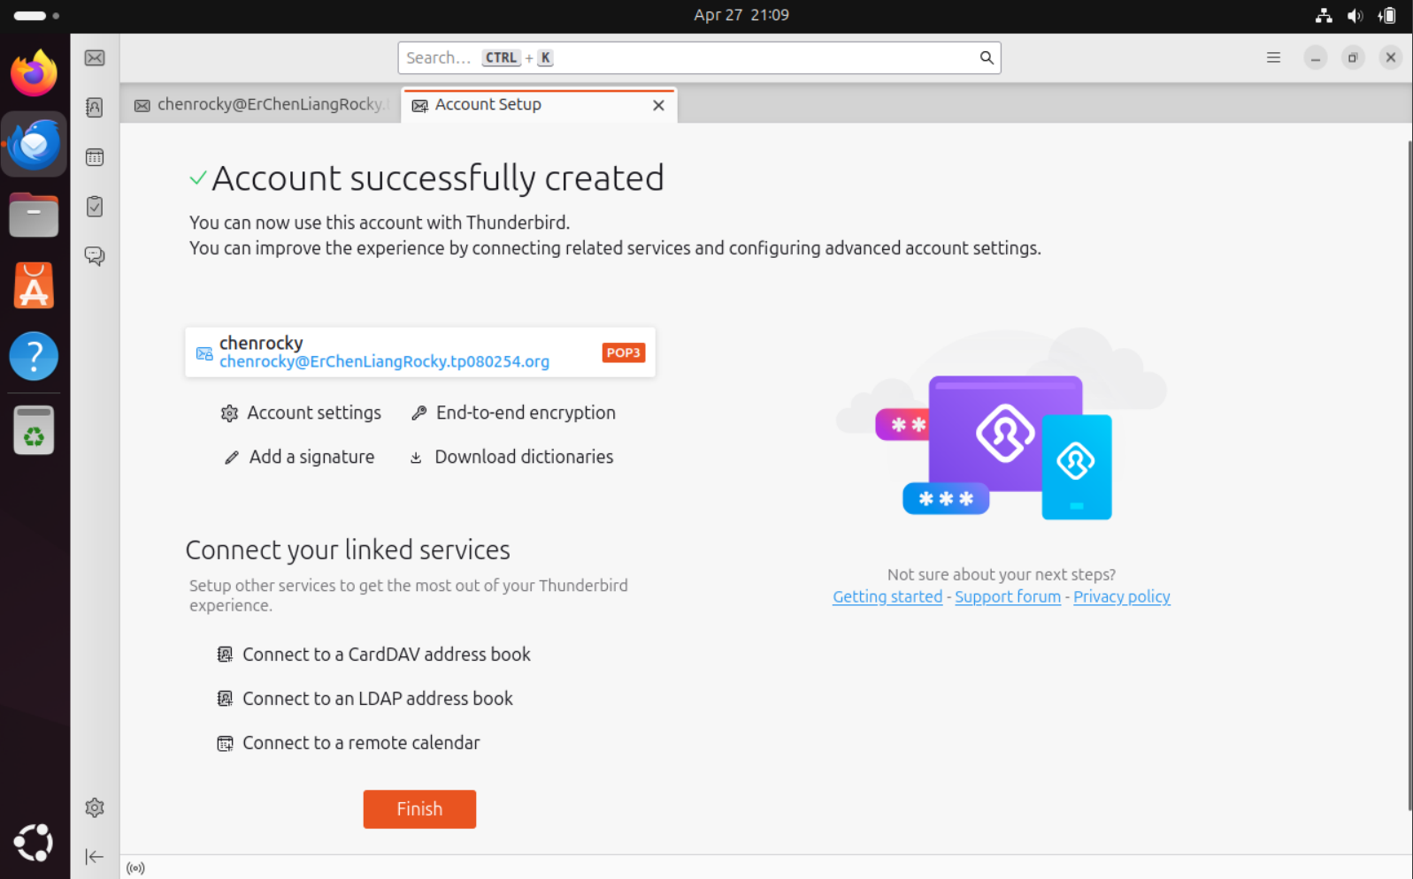



Figure 34

* Then we change to the mailbox page and click on the New Message Button.

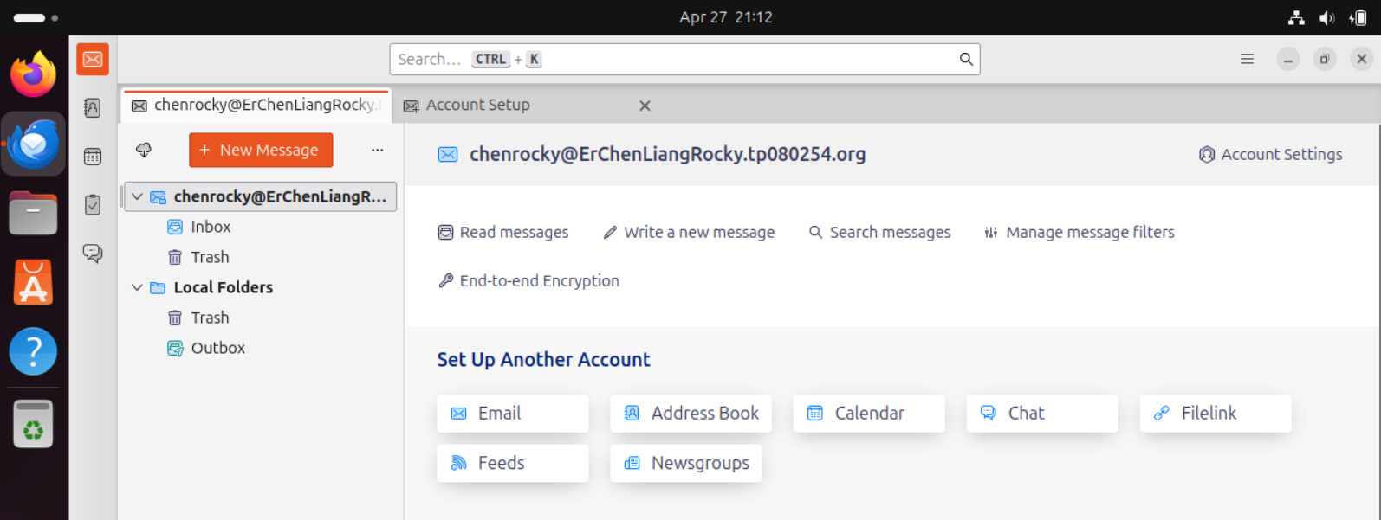



Figure 35

* Next, we can try to send the email.

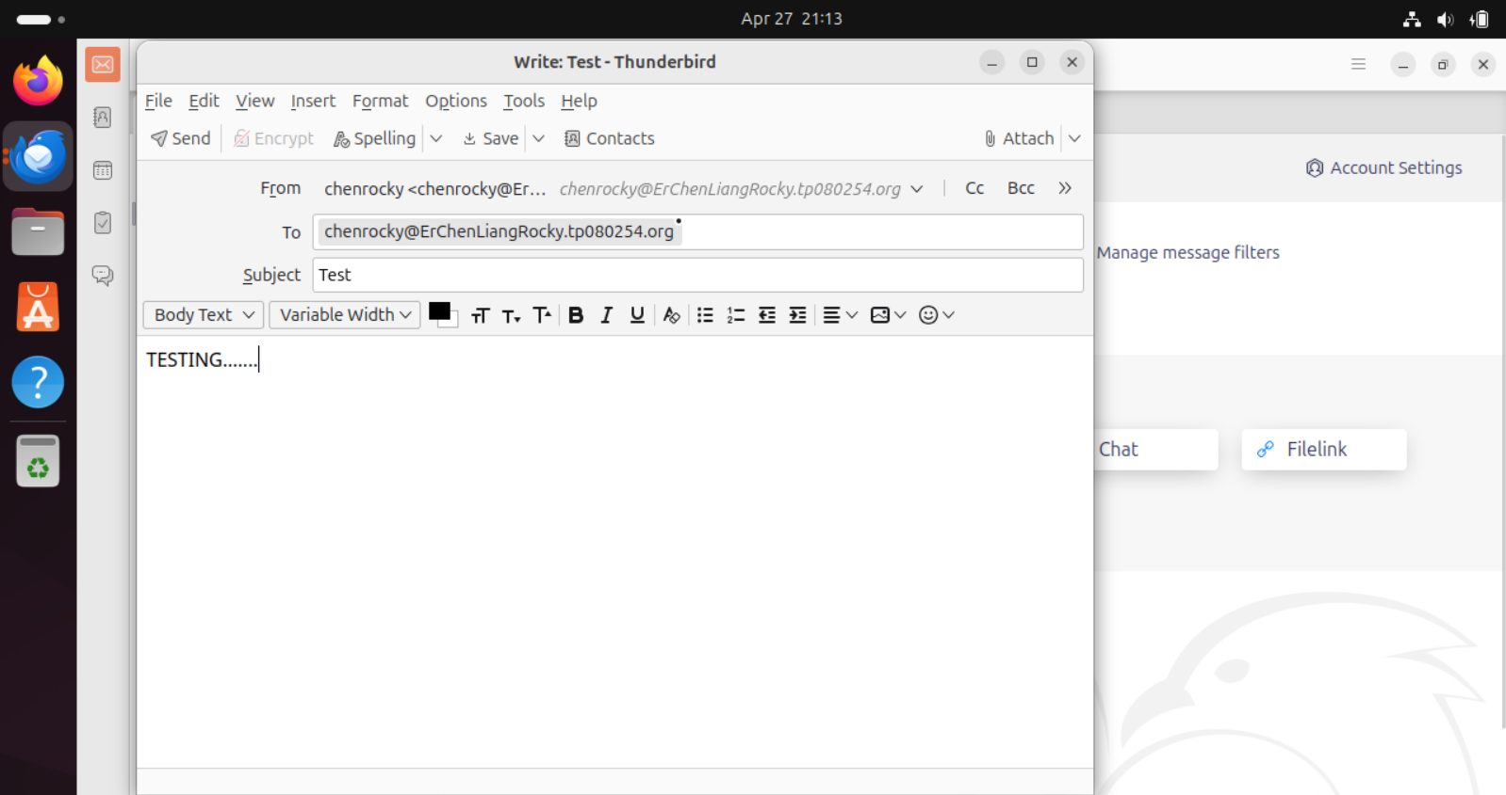



Figure 36

## **4.1.1 Problem Occurred**

After clicking the Send button, an error message appeared which is: “TLS not available due to local problem”.

* Although I previously stated that I did not want to use the default TLS certificate and private key, due to the fact that we have not set up our own certificate and private key. We now need to change the previous settings back in order to continue sending emails.

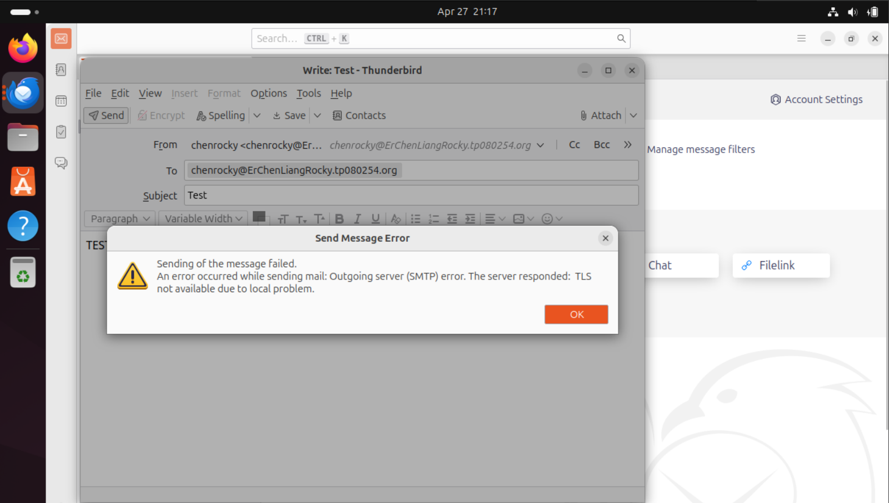

Figure 37

So, let us go back to our Rocky server terminal type the following command:

* sudo nano /etc/postfix/main.cf

(As we did before the TLS configuration is in this configuration file.)

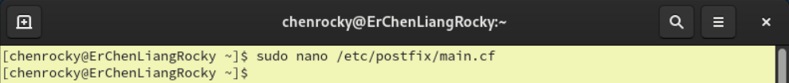



Figure 38

Then, find the TLS configuration, and below we find these two lines which is:

* #smtpd_tls_cert_file = /etc/pki/tls/cert/postfix.pem
* #smtpd_tls_key_file = /etc/pki/tls/private/postfix.key

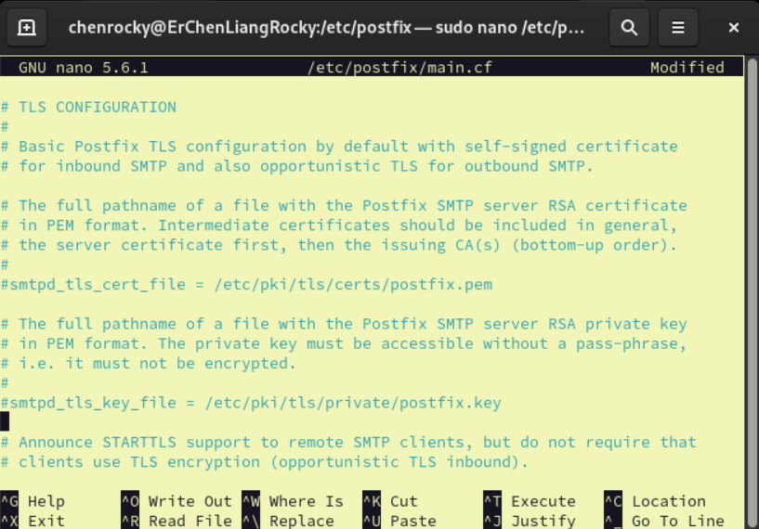



Figure 39

Uncomment them then save and close the nano.

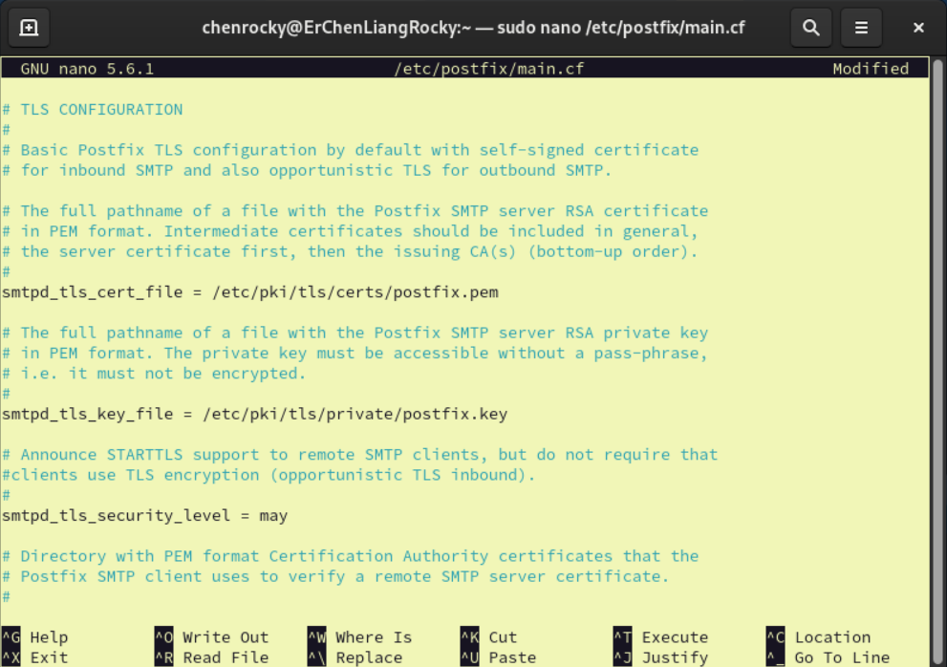



Figure 40

Next, restart the Postfix and enable the Postfix with the following command:

* sudo systemctl restart postfix
* sudo systemctl enable postfix

After that we type this command which can check the Postfix status:

* sudo systemctl status postfix

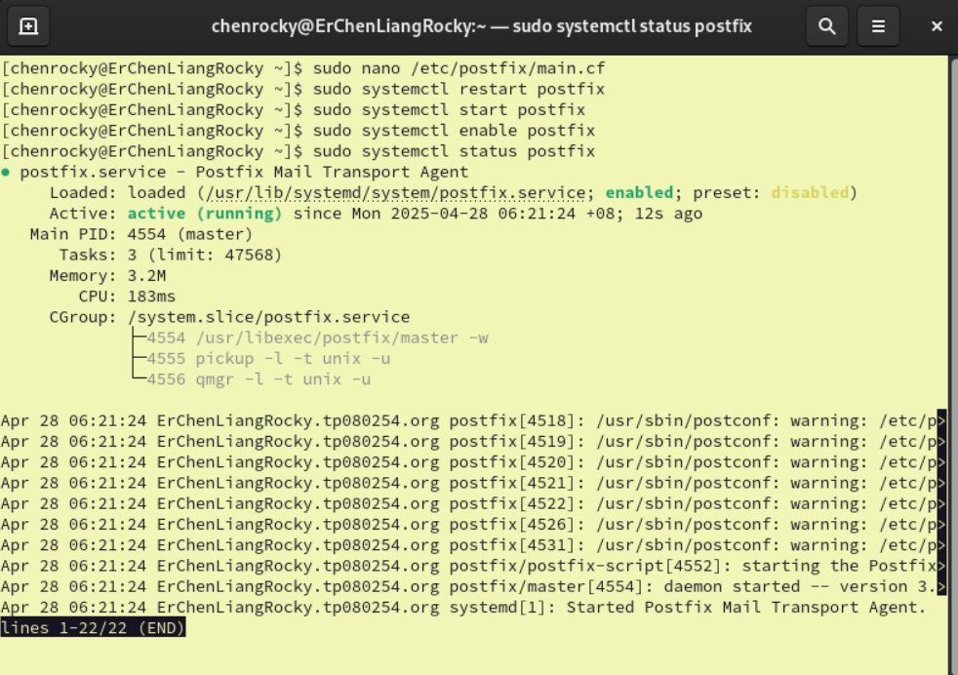



Figure 41

Afterwards, go back to ubuntu client and send the message again.

We can see the message is successfully sent. We can check the email we just sent it at the inbox.

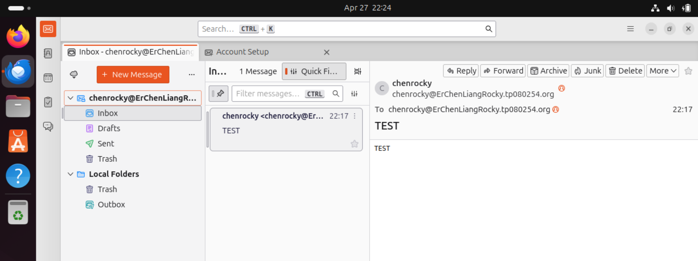



Figure 42

# **5.0 SSL/TLS Implementation**

**Step 1: Generate the SSL Certificate**

Install Openssl for generate the SSL certificate by typing the following command:

* sudo dnf install openssl

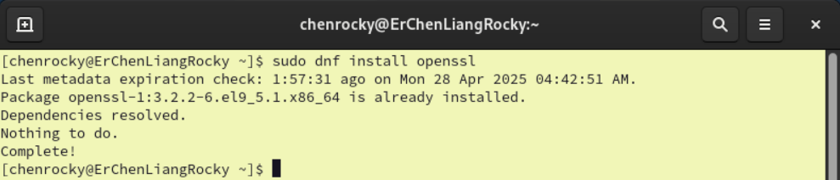



Figure 43

Next, we make two directory one is for the certificate and another one is for the private key.

* sudo mkdir -p /etc/ssl/private
* sudo mkdir -p /etc/ssl/certs





Figure 44

To generate the certificate, we type this command:

* sudo openssl req -x509 -nodes -keyout /etc/ssl/private/vsftpd-selfsigned.pem -out /etc/ssl/private/vsftpd-selfsigned.pem -days 365 -newkey rsa:2048

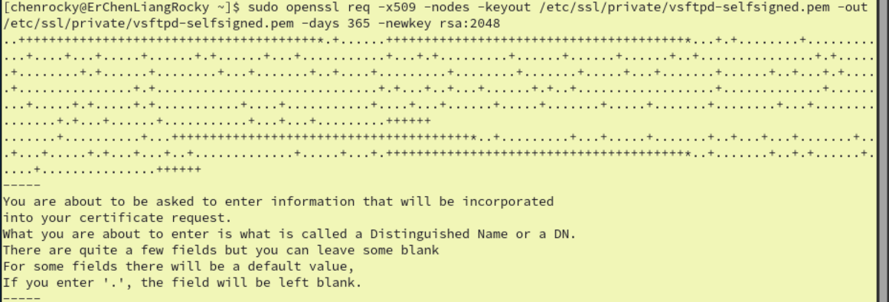



Figure 45

Then we fill up the certificate details on it including the server’s hostname and email address.

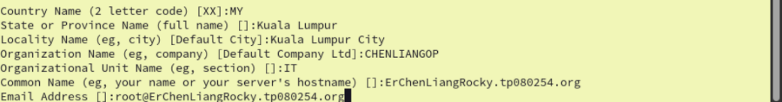



Figure 46

**Step 2: Configuring Postfix (SSL/TLS)**

Right now, we are ready to use our own TLS certificate and private key. Open the postfix main configuration file to configure the Postfix with our TLS certificate and private key.

* sudo nano /etc/postfix/main.cf





Figure 47

Next, we find the TLS configuration and delete these two lines:

* smptd_tls_cert_file = /etc/pki/tls/cert/postfix.pem
* smptd_tls_key_file = /etc/pki/tls/private/postfix.key

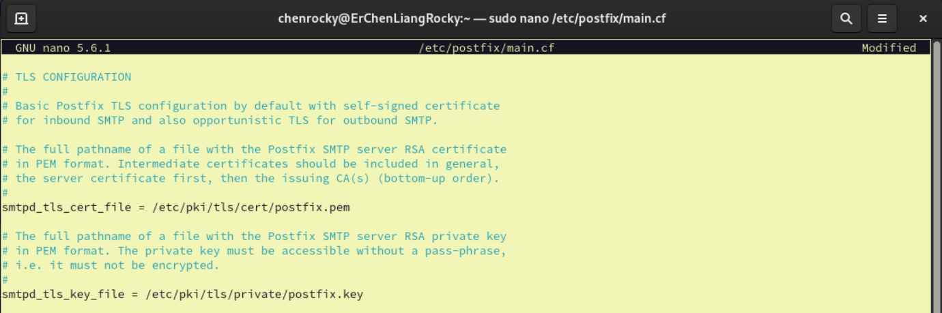



Figure 48

And we added these four lines at the end of the file:

* smtpd_tls_cert_file=/etc/ssl/private/vsftpd-selfsigned.pem
* smtpd_tls_key_file=/etc/ssl/private/vsftpd-selfsigned.pem
* smtpd_use_tls=yes
* smtpd_tls_session_cache_database = btree:${data_directory}/smtpd_cache

First two lines define the TLS certificate and private key used by Postfix. Third line is to enable TLS support on the Postfix SMTP server and the last line is to tell Postfix to store TLS session data using a btree-based database, which helps improve performance by caching session parameters for future connections.

Then save and close the nano.

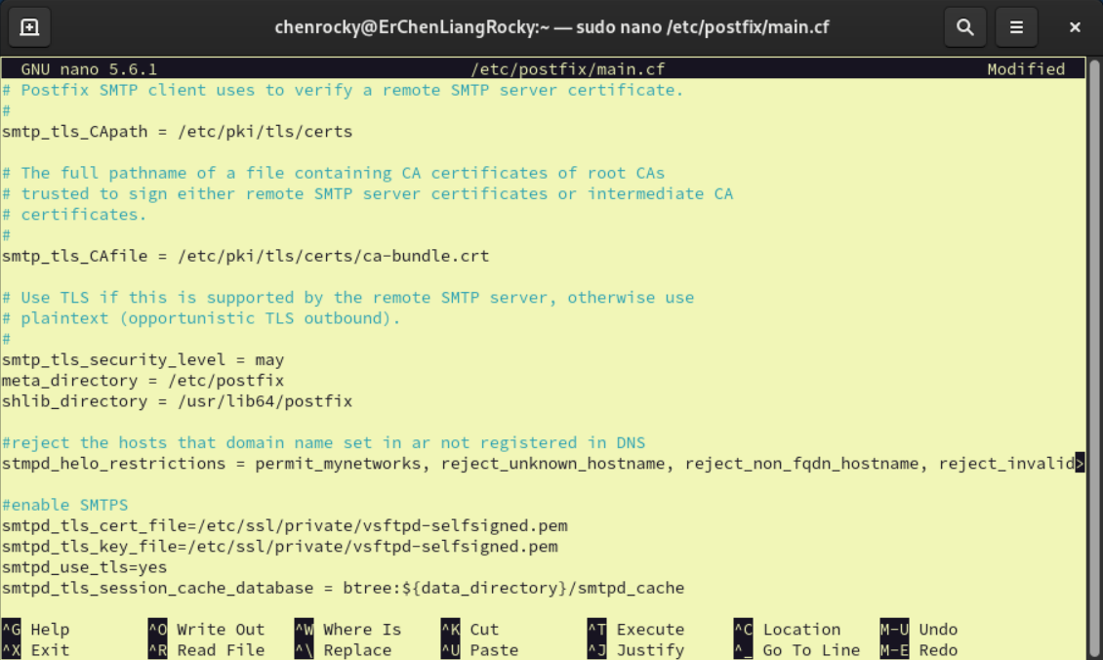



Figure 49

Next, we go to the master configuration of Postfix:

* sudo nano /etc/postfix/master.cf





Figure 50

Once we open the master configuration file we uncomment this following line:

* # -o syslog_name=postfix/submission
* # -o smtpd_sasl_auth_enable=yes
* # -o syslog_name=postfix/smtps
* # -o smtpd_tls_wrappermode=yes
* # -o smtpd_sasl_auth_enable=yes

These lines are associated with the submission port and SMTPS port. We uncomment then to enable logging under separate names for easier troubleshooting. Also, we enable SASL authentication, which is necessary for users to log in with a username and password. Then, we enable TLS encryption for Postfix and smtps port uses TLS wrapper mode, which encrypts the connections from start.

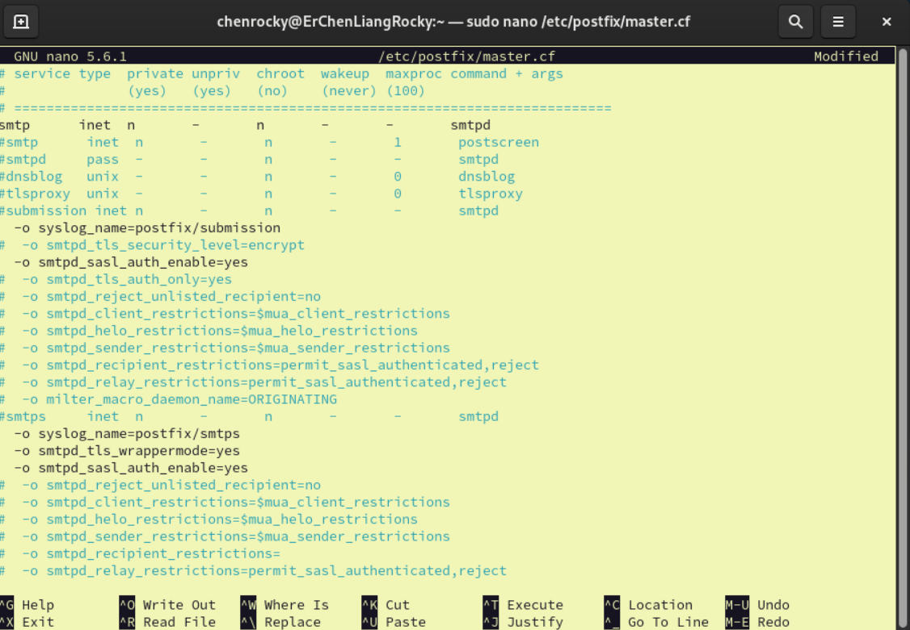



Figure 51

Then save and close the nano.

After we complete the configuration, restart the Postfix and check the status:

* sudo systemctl restart postfix
* sudo systemctl status postfix

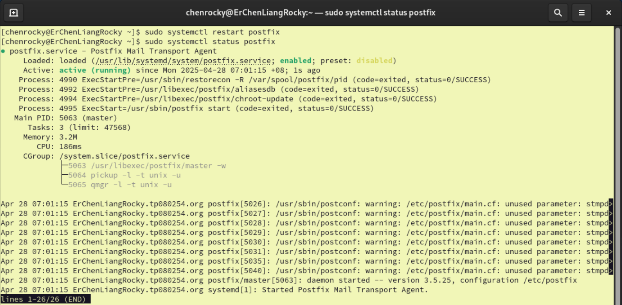



Figure 52

**Step 3: Configuring the Dovecot (SSL/TLS)**

Configure the SSL/TLS at the Postfix, next we configure the Dovecot configuration.

* sudo nano /etc/dovecot/conf.d/10-ssl.conf





Figure 53

we change these three lines by the following content:

* ssl = yes
* ssl_cert =</etc/ssl/private/vsftpd-selfsigned.pem
* ssl_key = </etc/ssl/private/vsftpd-selfsigned.pem

Then save and close the nano.

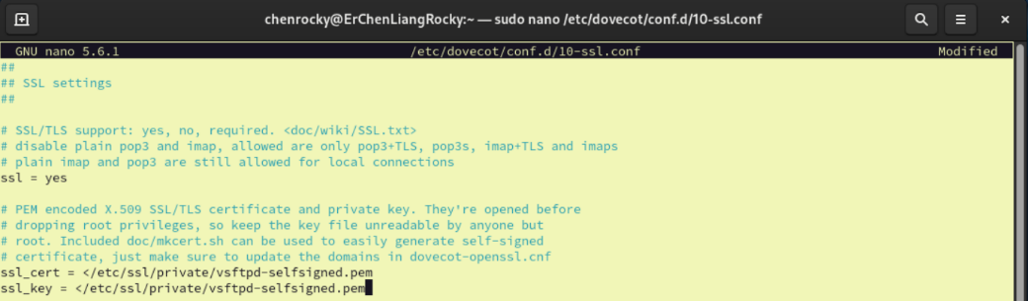



Figure 54

**Step 4: Configuring Thunderbird (SSL/TLS) Ubuntu**

To configure the Thunderbird, we open our it at the Ubuntu client, then we press the “hamburger menu” and find the “Account Settings”.

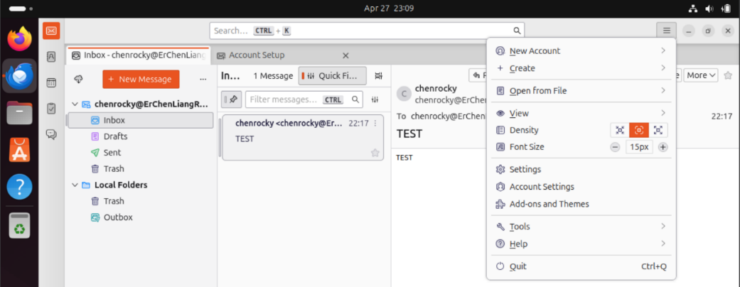



Figure 55

Inside the “Account Settings” we find “Outgoing Server(SMTP)”, next double clicks the server.

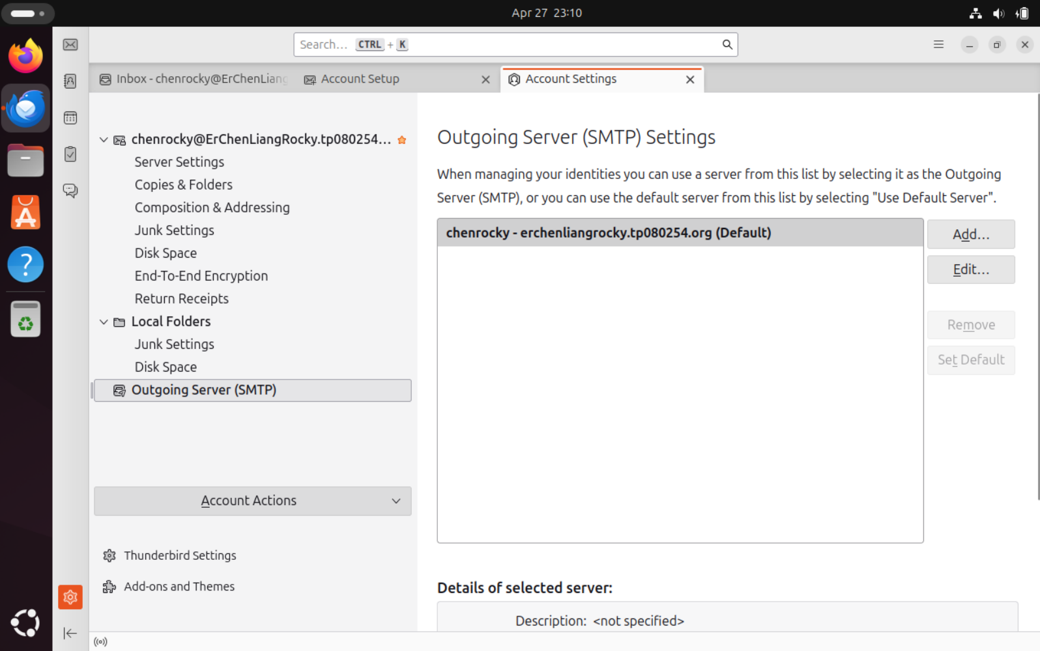



Figure 56

We change the server port to 465 and the connection security to SSL/TLS.

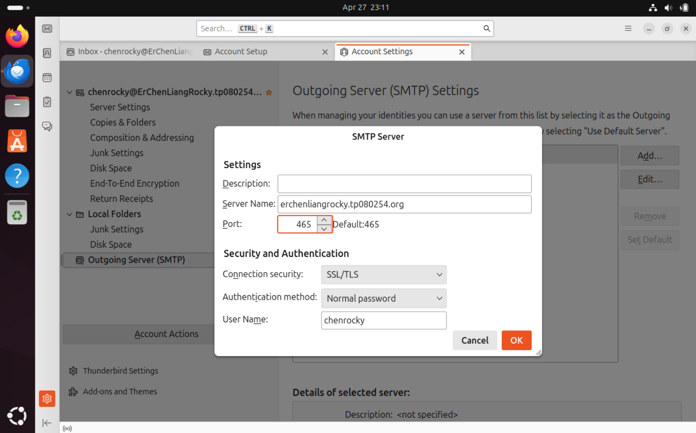



Figure 57

**Step 5: SSL/TLS Testing**

## **5.0.1 Problem Occurred**

After finishing the configuration of the Thunderbird in Ubuntu client the account exits automatically and shows that the configuration got something wrong.

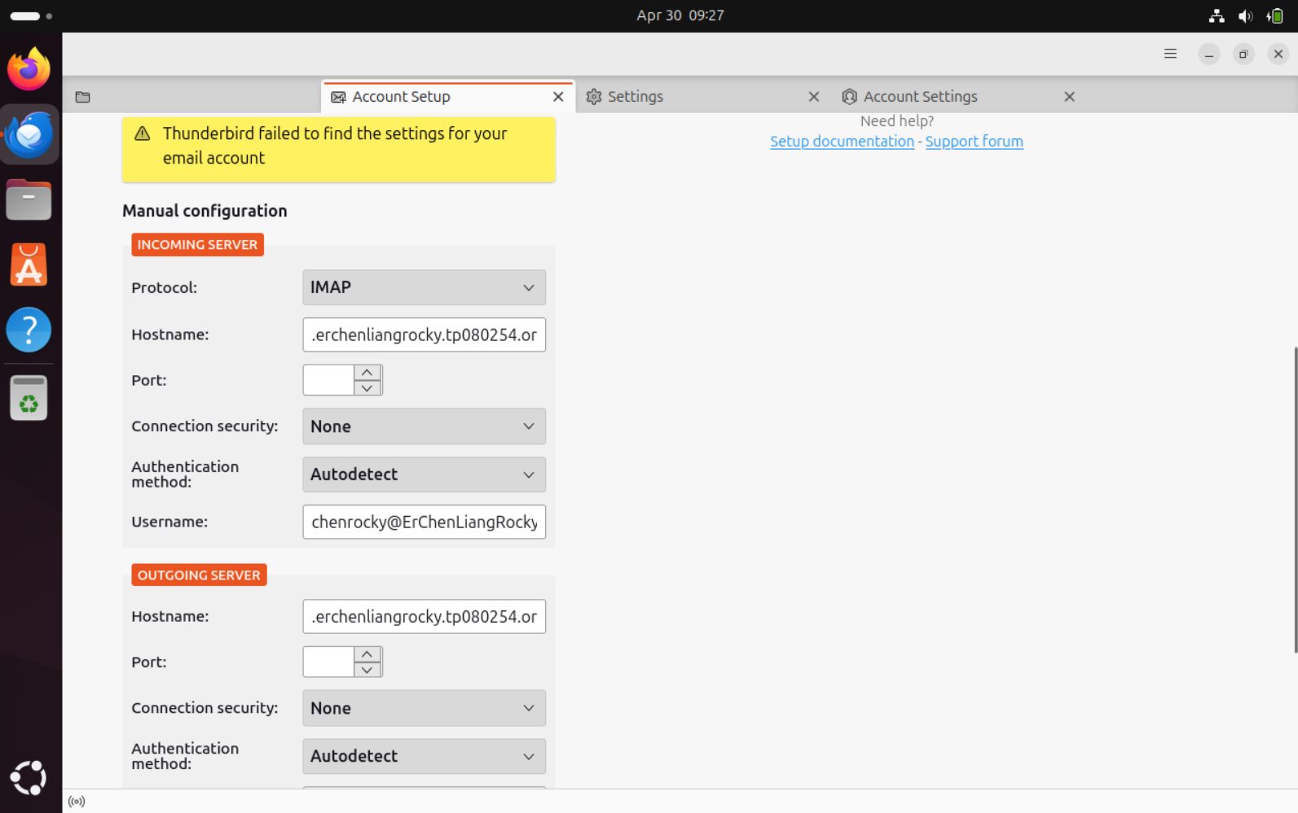

Figure 5

So, we go back to the Rocky server terminal and check the configuration of the Postfix configuration file.

* sudo nano /etc/postfix/main.cf





Figure 5

We go to the end of the Postfix configuration file and check if we have typo or not,  
but here we need to add more lines which is:

* smtpd_sasl_type=dovecot
* smtpd_sasl_path=private/auth
* smtpd_sasl_auth_enable=yes

and here we forget these lines which are essential for allowing authenticated users to send email through Postfix. Without them, even with the correct username and password, the Thunderbird would still fail.

Then press Ctrl+X to quit nano, press Y to save and press Enter to Close the nano.

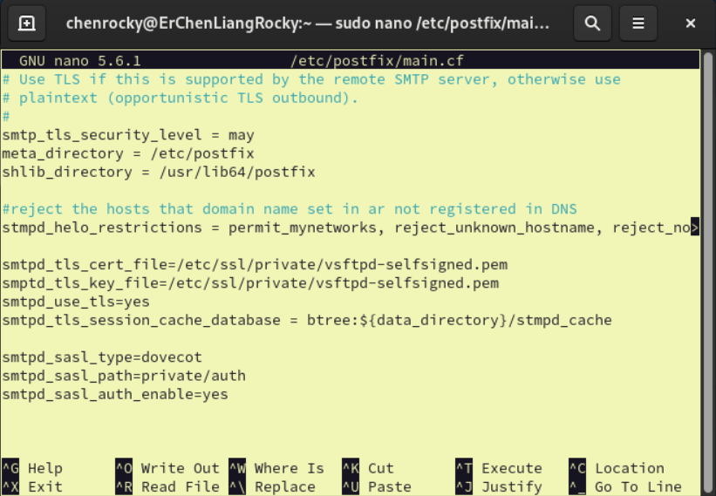



Figure 60

Next, we added the forgotten firewall to the port 587 and port 465 and reload them:

* sudo firewall-cmd --permanent -add-port=587/tcp
* sudo firewall-cmd --permanent -add-port=465/tcp
* sudo firewall-cmd --reload

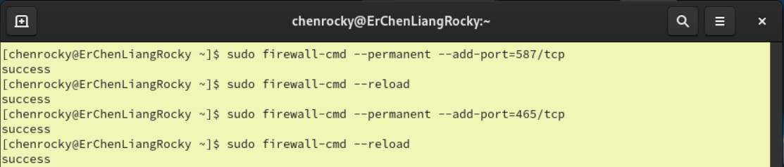



Figure

After finishing the troubleshoot of the configuration file, we go back to the ubuntu client and try to create the Thunderbird again.

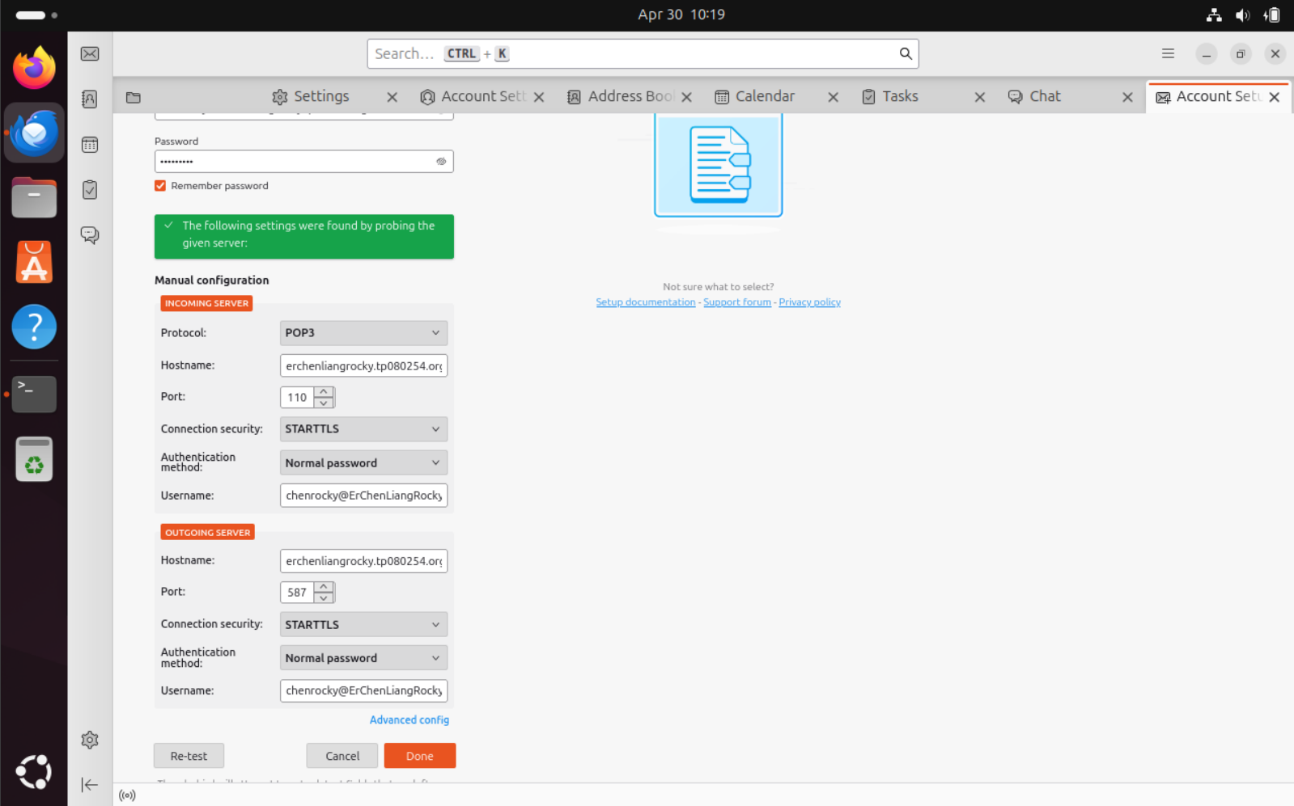

Figure 62

We created the account successfully.

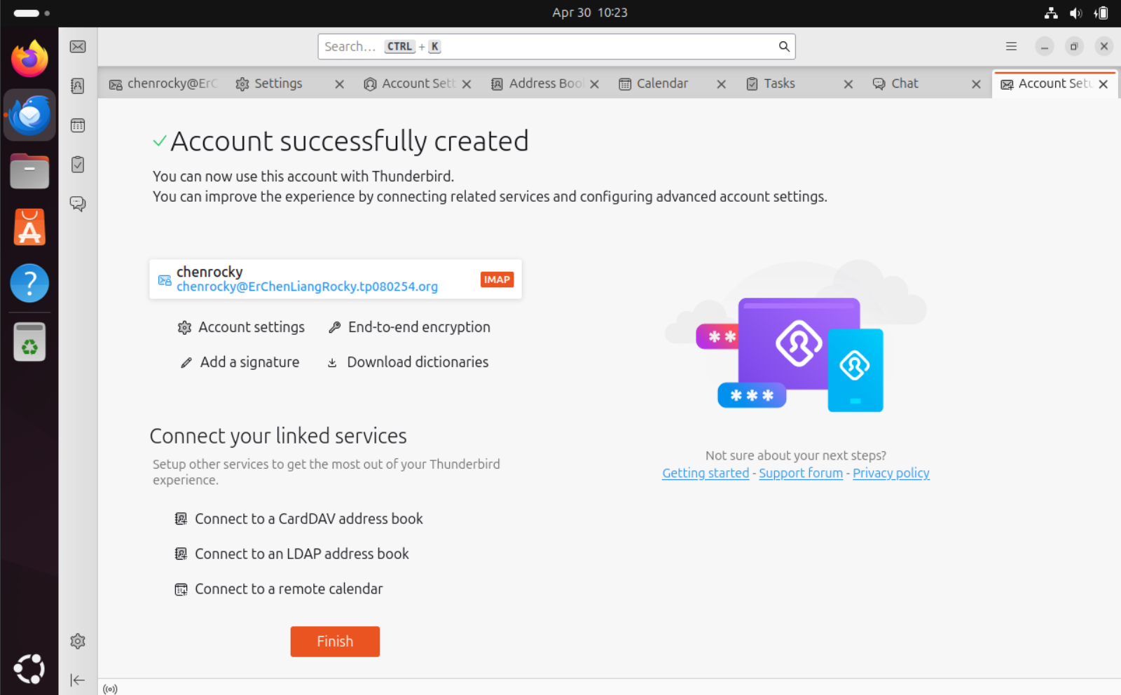

Figure 63

## **5.0.2 Problem Occurred**

When we try to send the email. An error occurred.

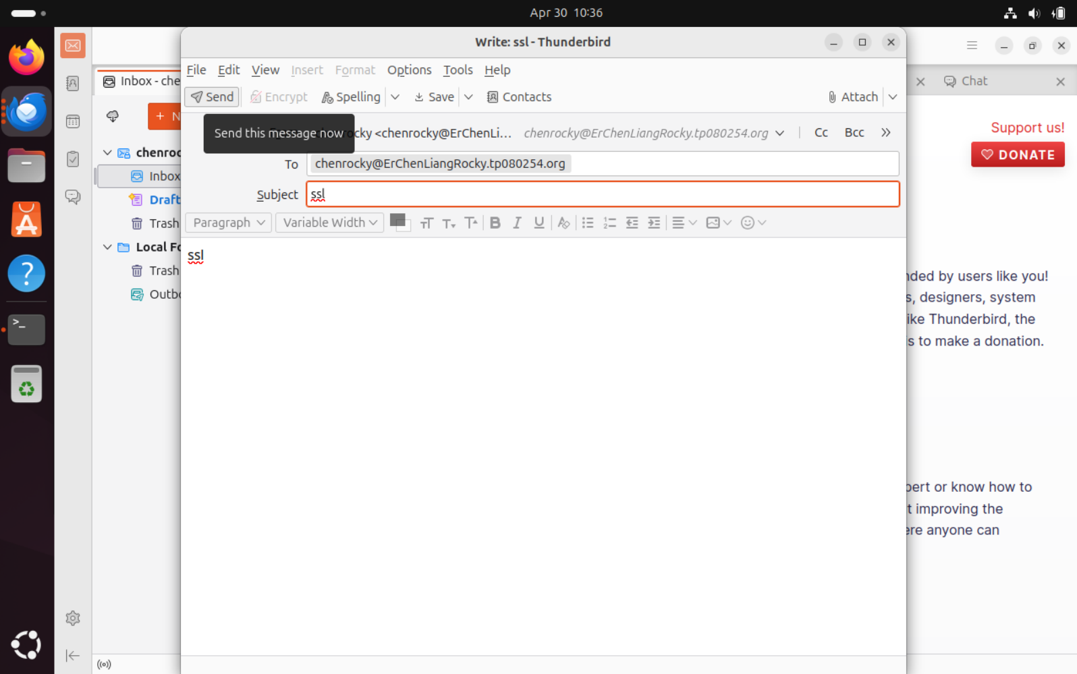



Figure 64

The error message appears and shows that the server is refusing the SMTP connection.

So, we go back to the Rocky Server to Troubleshoot the Postfix SMTP.

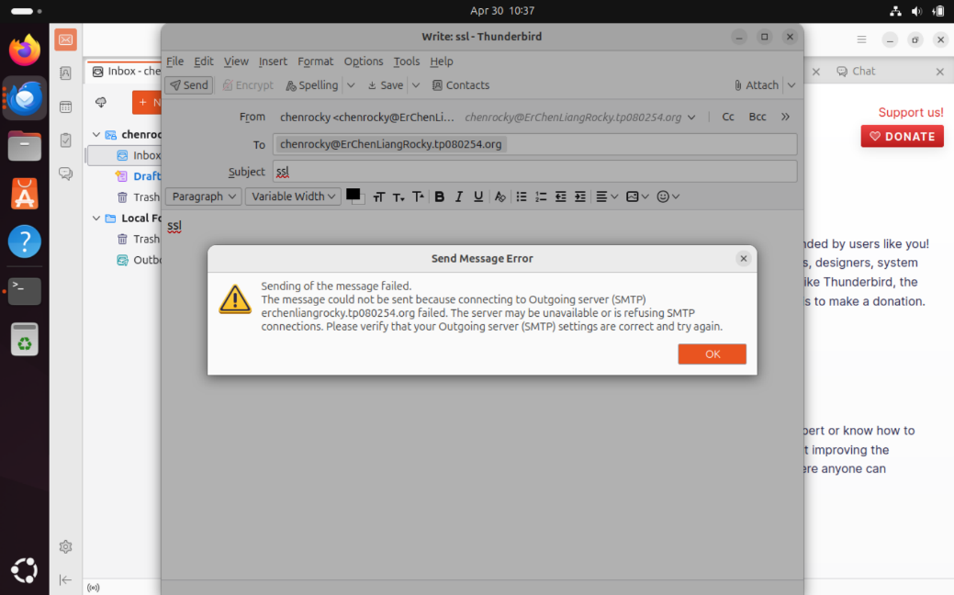

Figure 65

We go to the master configuration file of Postfix:

* sudo nano /etc/postfix/master.cf

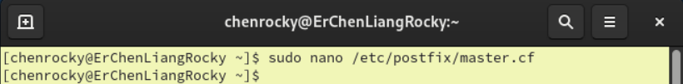



Figure 66

Find the following comment line and uncomment it:

* #submission inet n - n - - smtpd

Then save and close the nano.

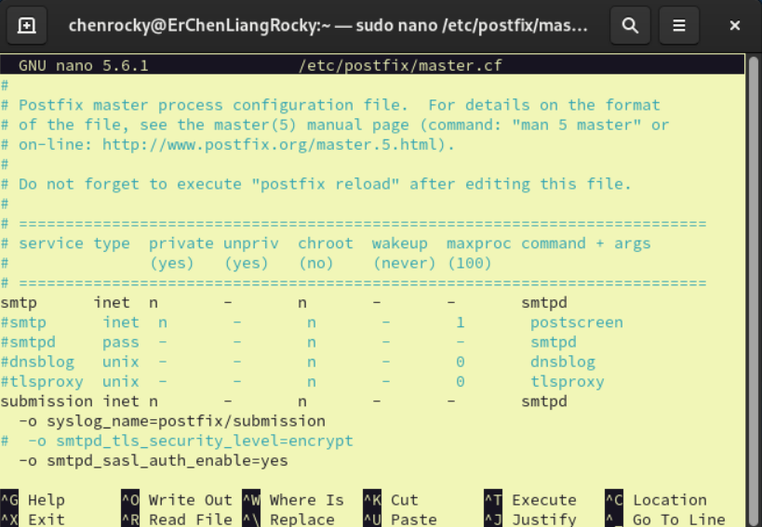



Figure 67

Next, restart the postfix:

* sudo systemctl restart postfix

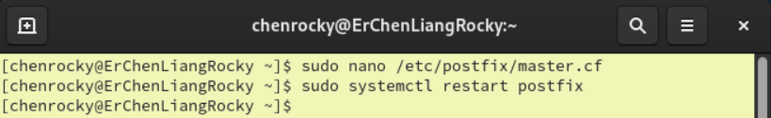



Figure 68

After we troubleshoot the Postfix SMTP, we change the port number to the SMTP port which is 587. Then, we click the” OK button”.

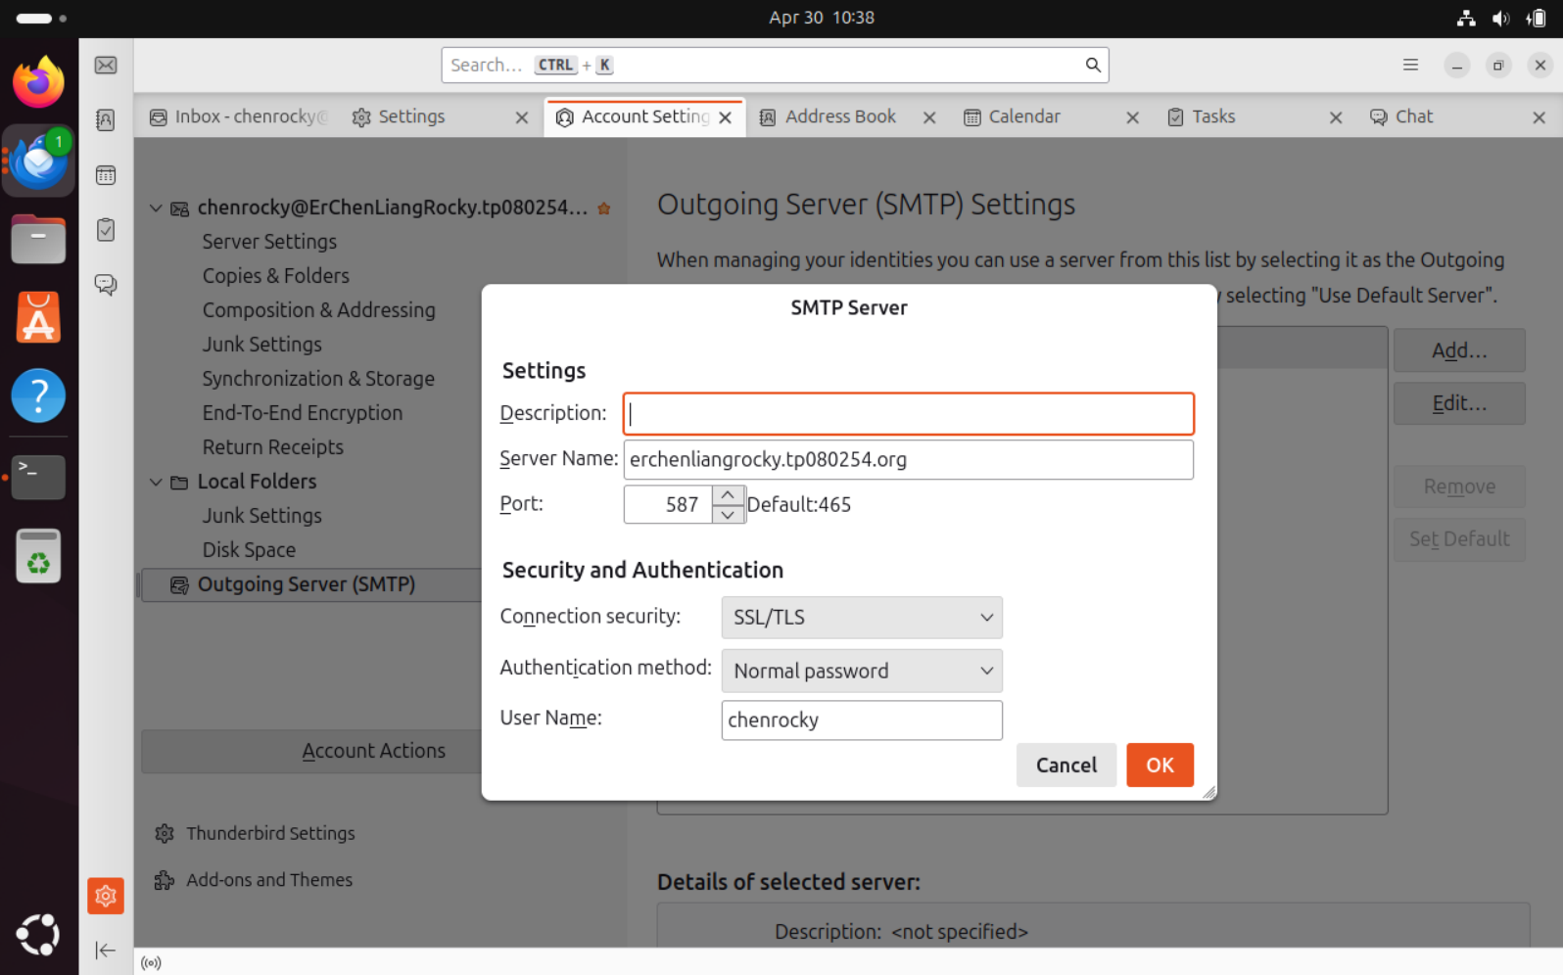



Figure 69

Next, we try to send the emails again.

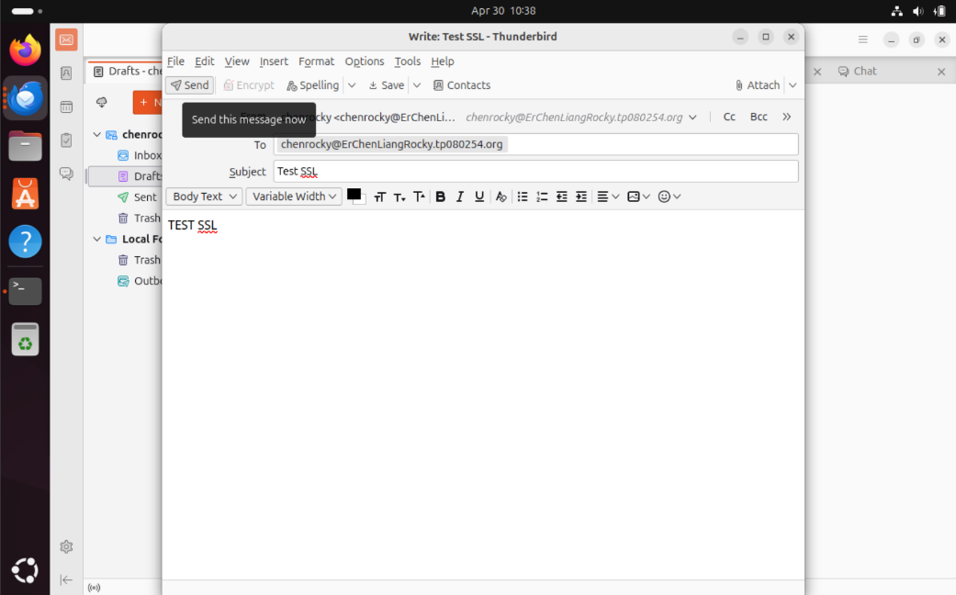



Figure 70

The email successfully sent we can see the notification of the Thunderbird appear and the new email has appeared inside the inbox.

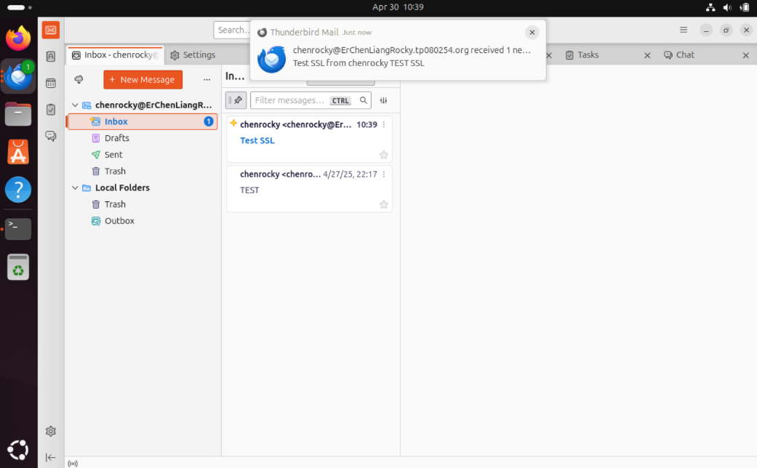

Figure 71

We can open the emails and check is this the email we sent.

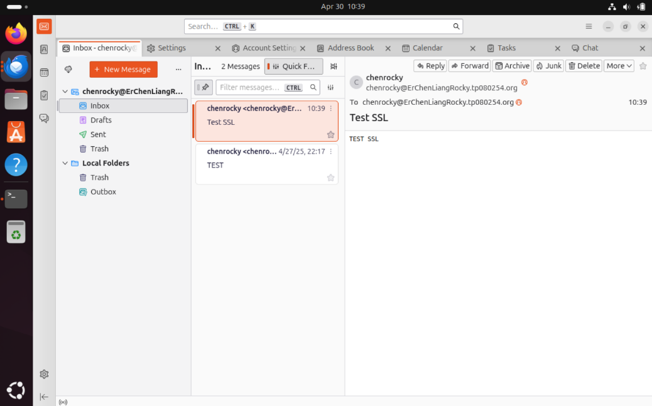



Figure 72

If the email is sent then our SSL configuration is success.

# 6.0 Additional (Spam Assassin)

**Step 1: Installed Spam Assassin**

Install Spam Assassin by typing the following command:

* sudo dnf install spamassassin

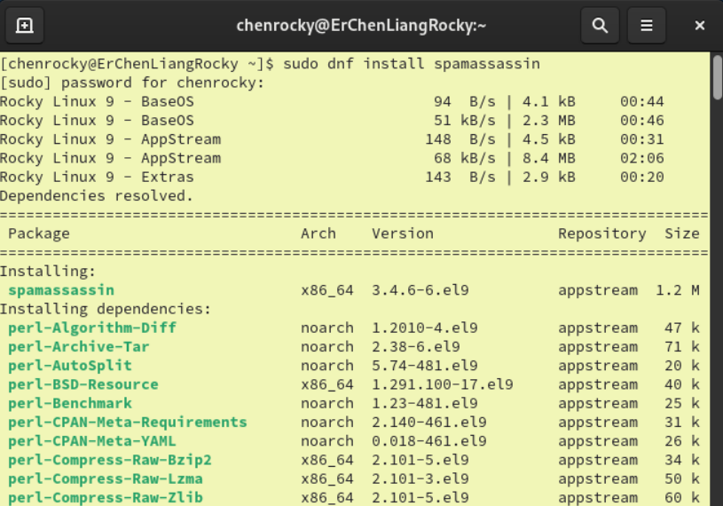



Figure 73

Then we start the Spam Assassin and enable it.

* sudo systemctl start spamassassin
* sudo systemctl enable spamassassin

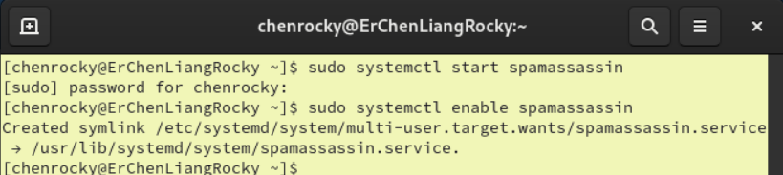



Figure 74

**Step 2: Configuration of Postfix**

Open the master configuration file of Postfix:

* sudo nano /etc/postfix/master.cf

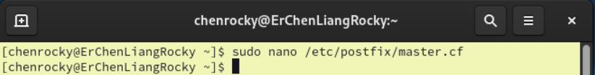



Figure 75

Next, we add the new line:

* -o content_fliter=spamassassin

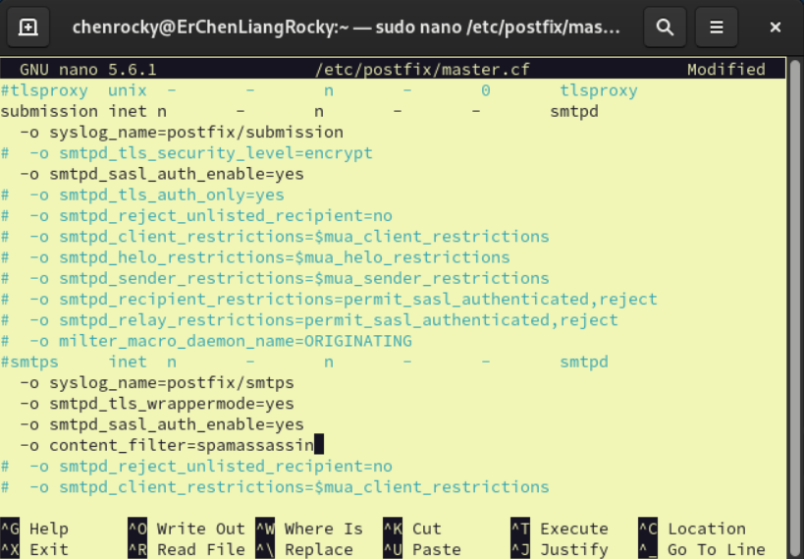



Figure 76

We go to the end of the file and add more lines which is:

* spamassassin unix - n n - - pipe
* user=nobody argv=/usr/bin/spamc -f -e /usr/sbin/sendmail -oi -f ${sender} ${recipient}

**Explanation:**

user=nobody tells Postfix to run spamc under the safe nobody user.

spamc -f -e /usr/sbin/sendmail ...:

* -f tells spamc to filter the message
* -e pipes the message to Postfix's sendmail for final delivery

Then save and close the nano.

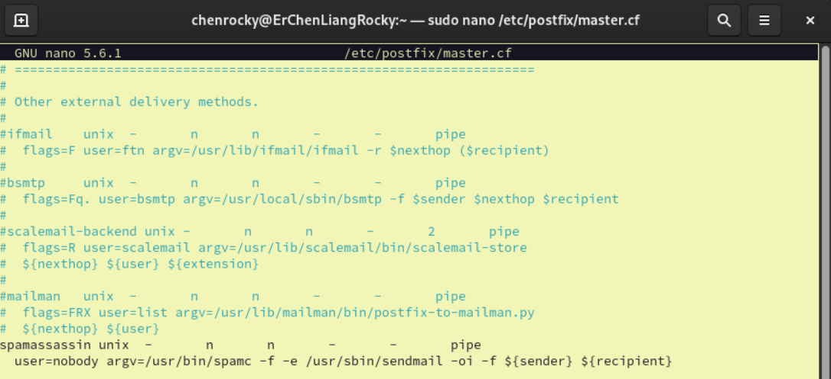



Figure 77

Open the main configuration file of Postfix:

* sudo nano /etc/postfix/main.cf

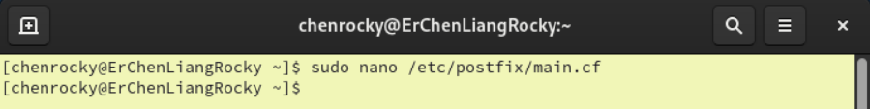



Figure 78

We go to the end of the file and add more lines which is:

* receive_override_options=no_address_mappings
* header_checks=regexp:/etc/postfix/header_checks

Explanation:

* receive_override_options=no_address_mappings can prevent Postfix from rewriting email addresses when mail is re-injected
* header_checks=regexp:/etc/postfix/header_checks tells Postfix to apply regular expression checks to email headers

Then save and close the nano.

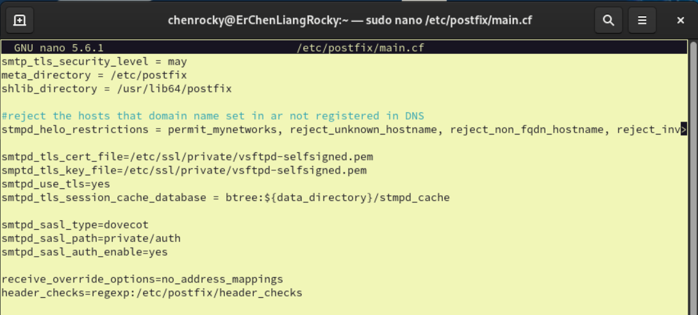



Figure 79

Next, we open the Postfix header checks file:

* sudo nano /etc/postfix/header_checks

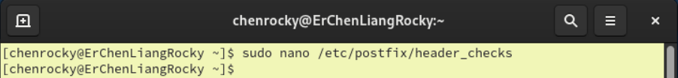



Figure 80

Then, at the end of the file we add the following line:

* /^X-Spam-Checker-Version:/ IGNORE

Then save and close the nano.

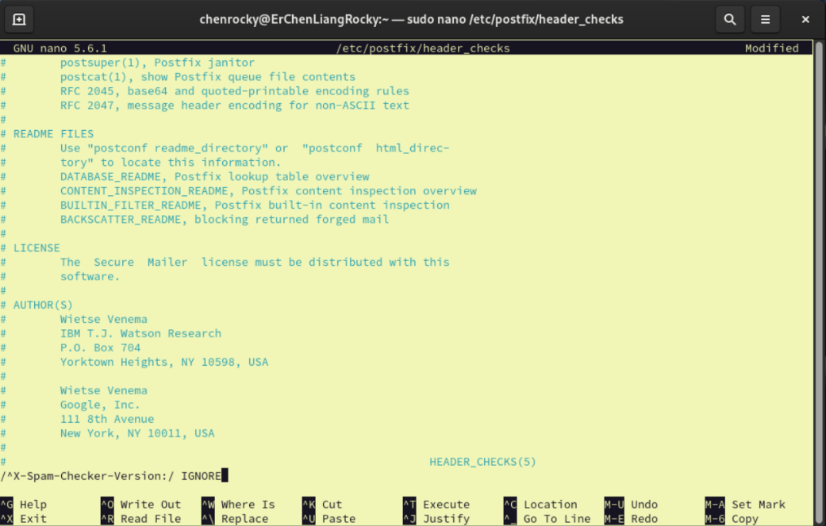



Figure 81

**Step 3: Configuration of Spam Assassin**

Open the Spam Assassin local configuration file:

* sudo nano /etc/mail/spamassassin/local.cf

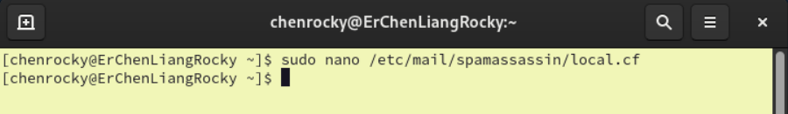



Figure 82

Then we add the following lines:

* required_hits 5
* report_safe 0
* rewrite_header Subject [SPAM]
* use_bayes 0
* bayes_auto_learn 0
* user_preferences_file /dev/null

Explanation:

required_hits 5: Set the spam threshold score

report_safe 0: Don’t wrap spam in a MIME attachment.

rewrite_header Subject [SPAM]: Adds [SPAM] to the subject line of detected spam.

use_bayes 0: Disable Bayesian filtering.

bayes_auto_learn 0: Prevent SpamAssassin from learning new spam/ham automatically.

user_preferences_file /dev/null: Forces SpamAssassin to ignore per-user config files that nobody can’t access.

Then save and close the nano.

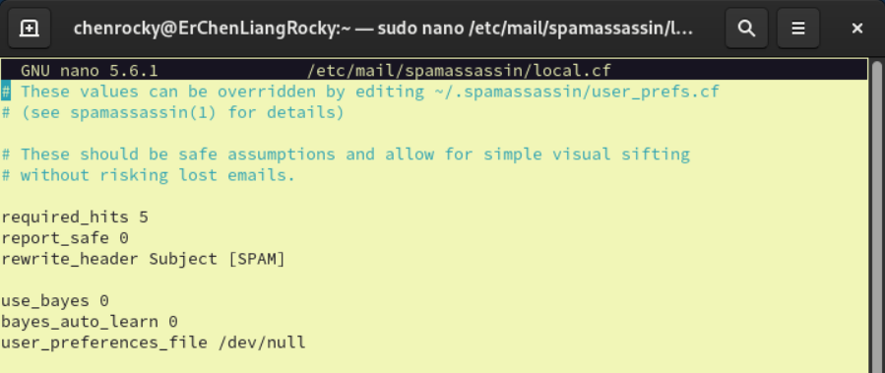



Figure 83

After finishing all the configuration, we restart the Postfix and Spam Assassin.

* sudo systemctl restart postfix
* sudo systemctl restart spamassassin

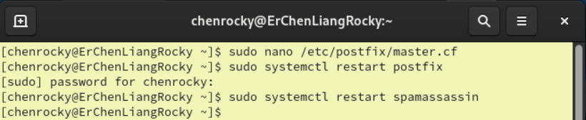



Figure 84

**Step 4: Testing Spam Assassin**

In Thunderbird try to send a test email containing the GTUBE test string (standard test for spam filters). Verified that SpamAssassin detected the spam:

(XJS*C4JDBQADN1.NSBN3*2IDNEN*GTUBE-STANDARD-ANTI-UBE-TEST-EMAIL*C.34X)

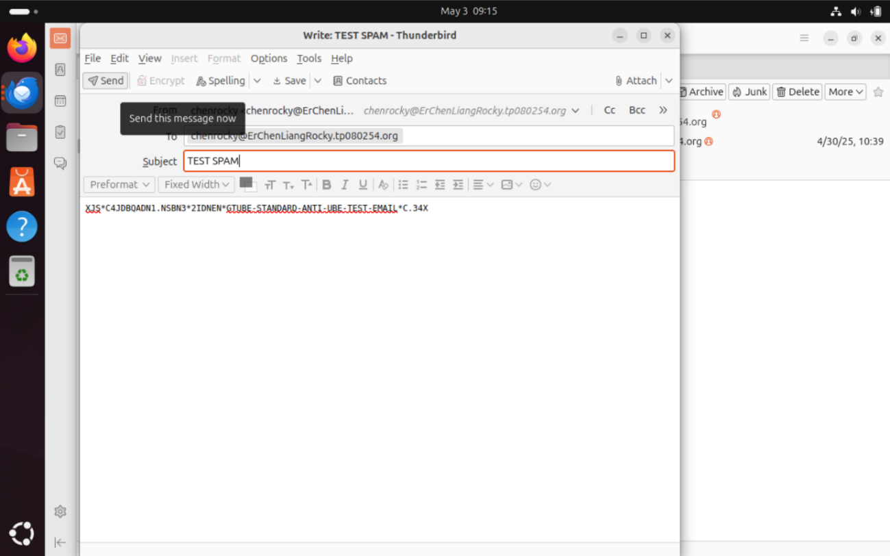



Figure 85

When the email sent the TEST SPAM email was rewritten as [SPAM] TEST SPAM

This mean that the Spam Assassin correctly scanned the email.

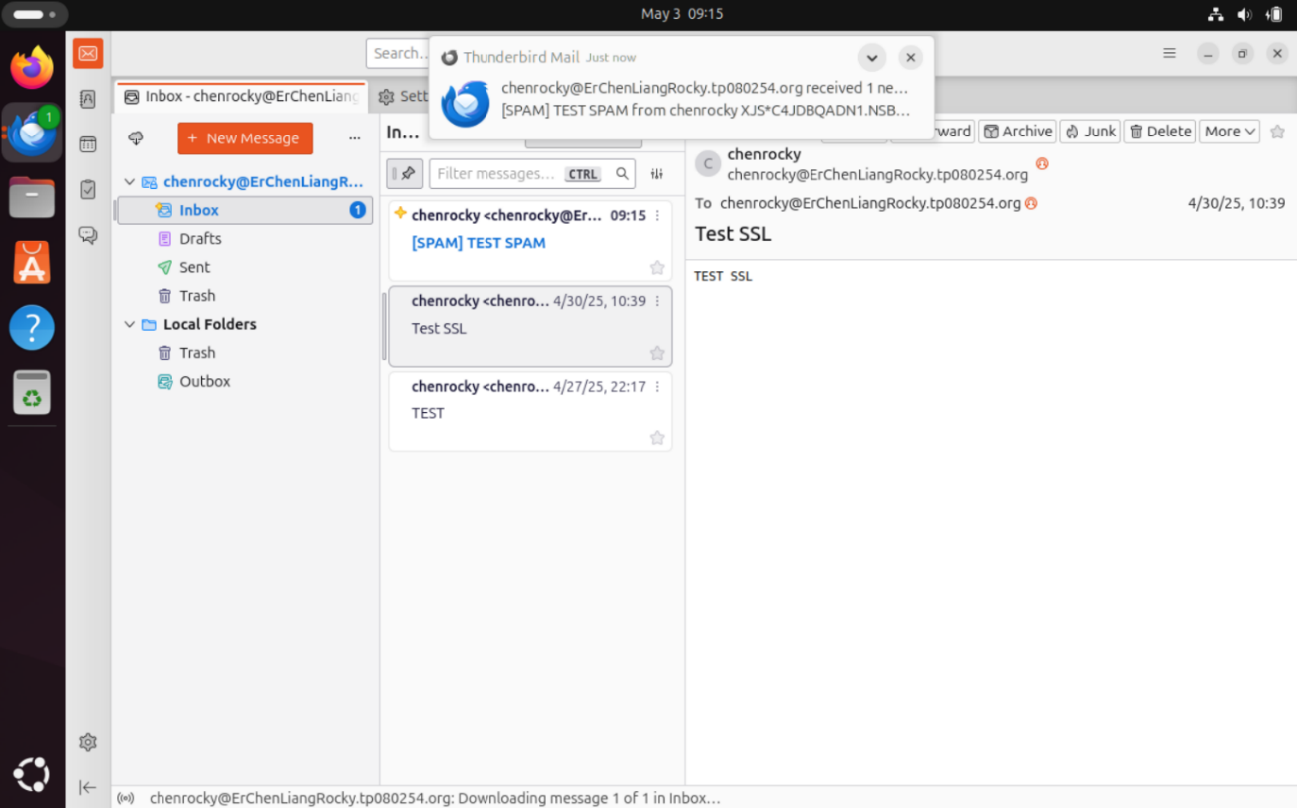



Figure 86

Next, we click into the email and find the View Source.

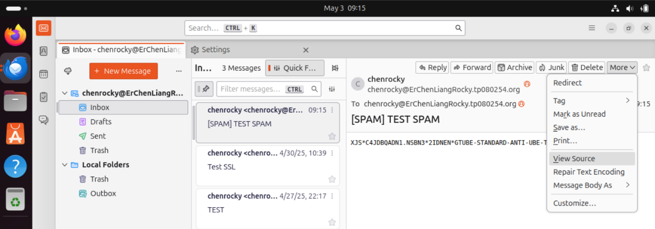



Figure 87

At the Source code of the email, we can see that:

* X-Spam-Flag: YES
* X-Spam-Level: ****************************************************************
* X-Spam-Status: Yes, score=1000.0 required=5.0 tests=ALL_TRUSTED,GTUBE

Which mean that the GTUBE was detected!

This confirms that SpamAssassin is working correctly, successfully filtering and tagging spam messages in the mail server pipeline.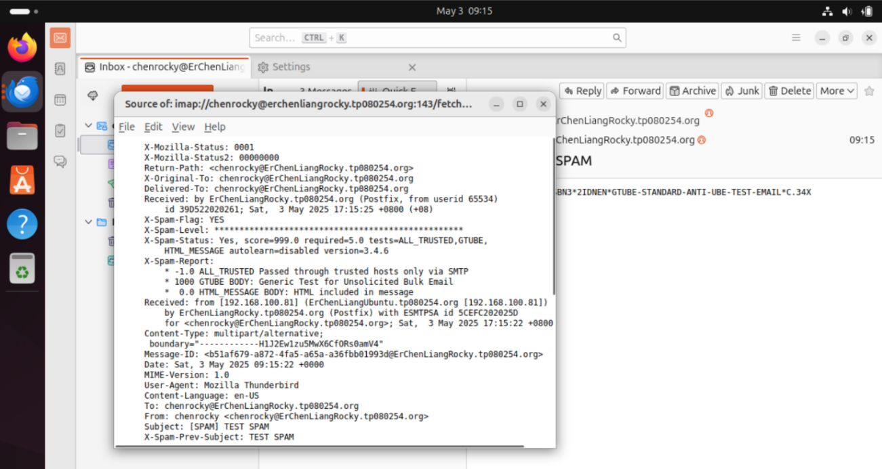



Figure 88

# 7.0 Testing

First, we open our Thunderbird at Ubuntu client and create another new user account that we have on Rocky server.

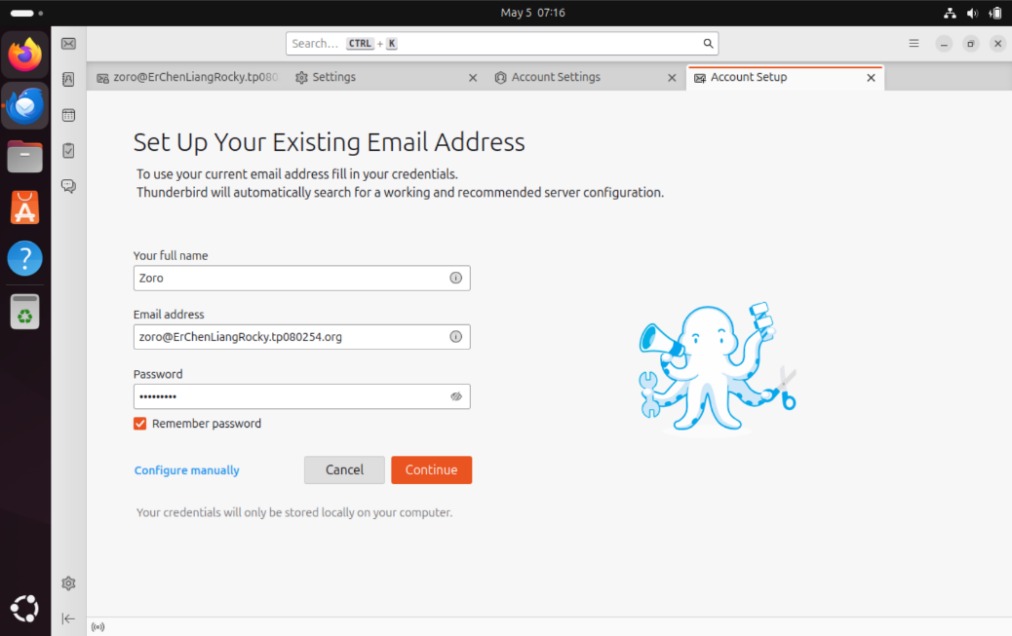

Figure 89

After we create the account successfully, we can see that there are two accounts in our Thunderbird which allow us can send emails to each other.

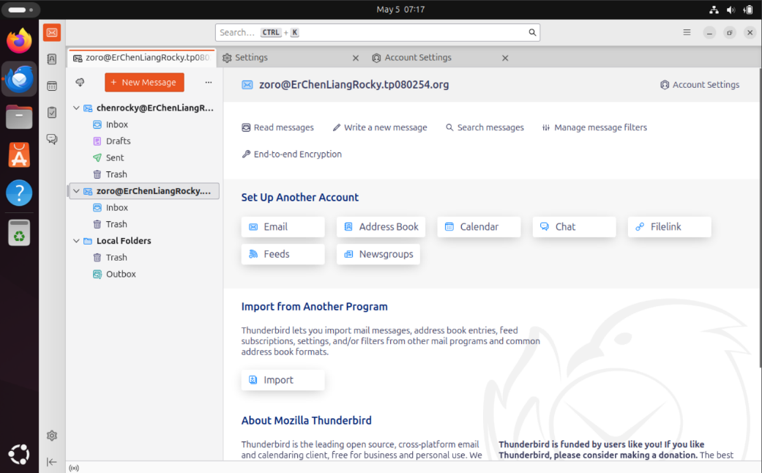

Figure 90

Next, clicks on the zoro account and send the message by clicking the New Message button.

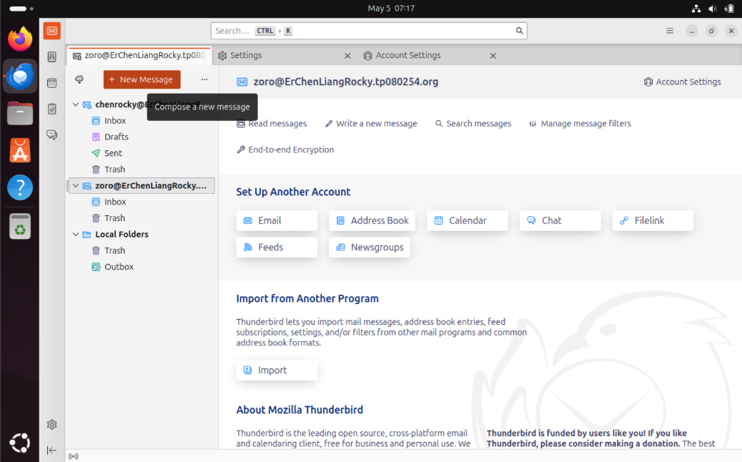

Figure 91

Type in the chenrocky email address and simply type anything in the subject and content. Then click the Send button.

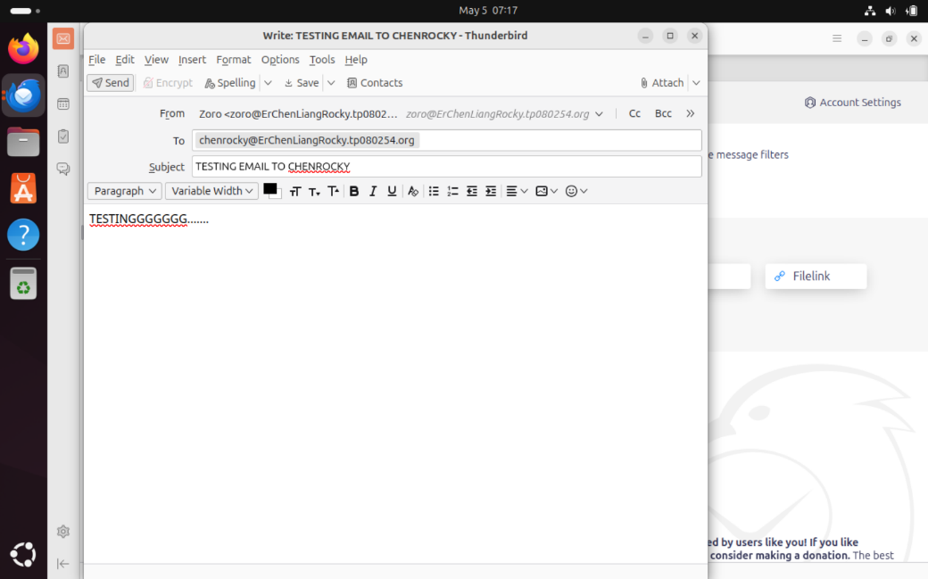

Figure 92

After clicking the Send button, we can switch to the chenrocky and it will show the receive email which sent from the zoro.

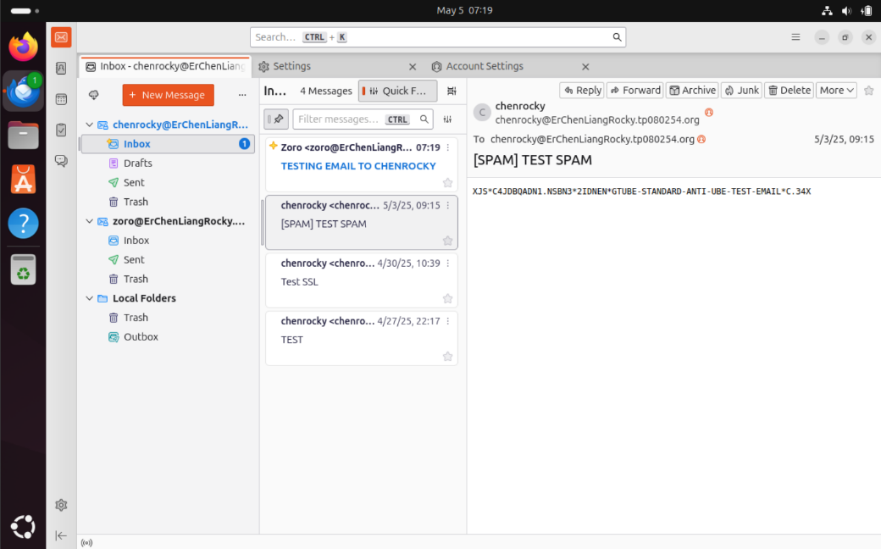

Figure 93

We can double click on the email and try to view the email source.

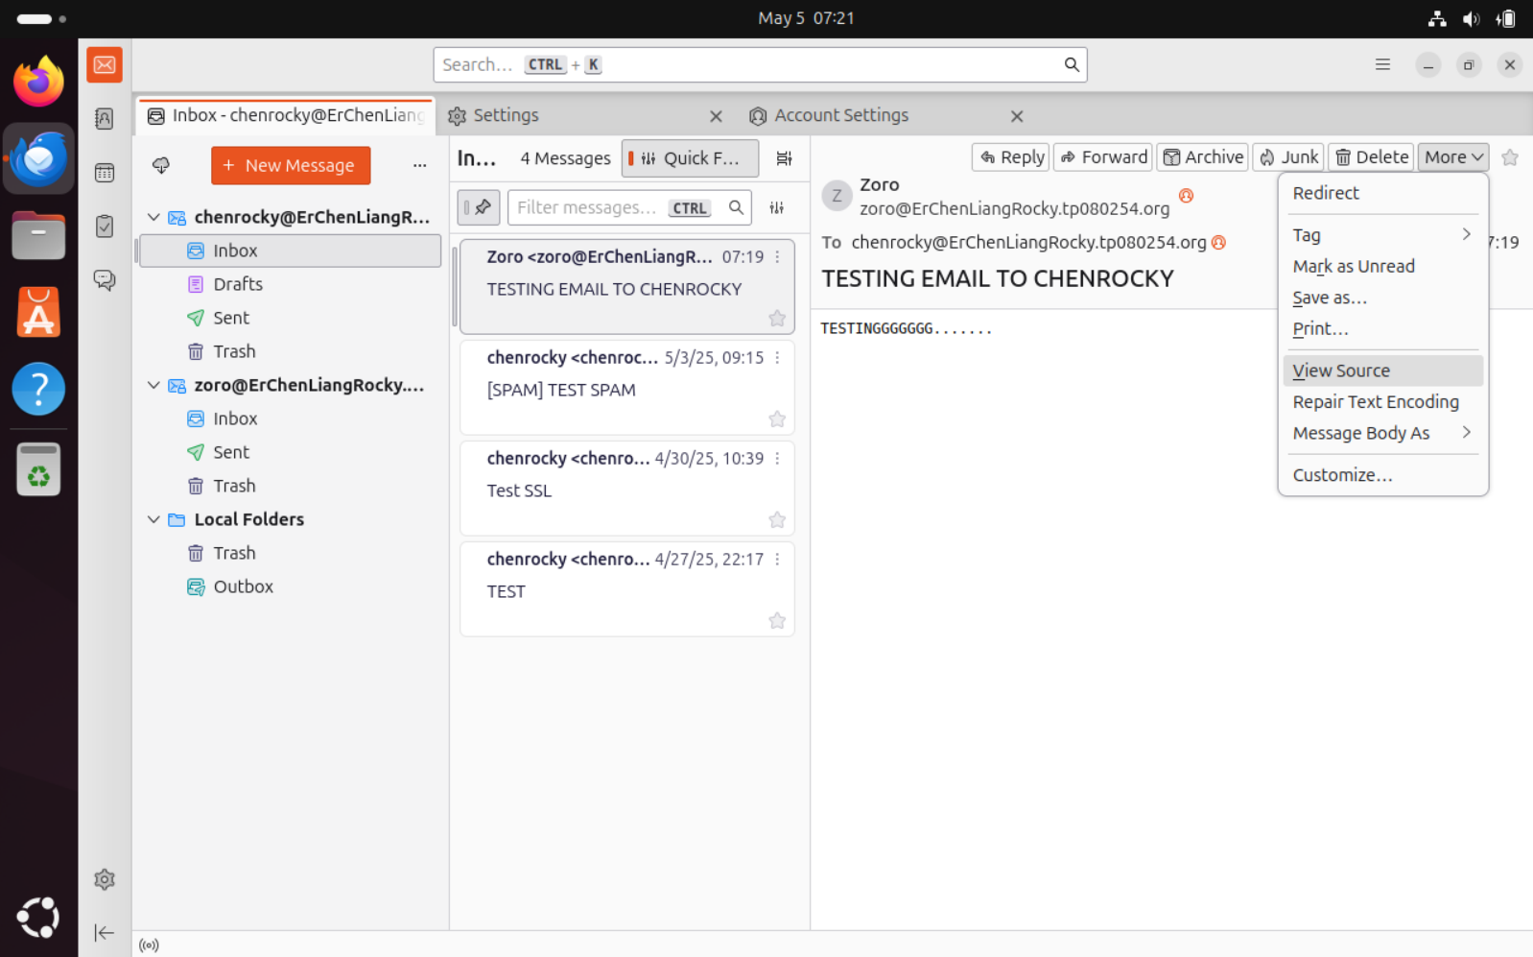

Figure 94

As we can see the Spam Assassin is also functioning perfectly which mean that all the configuration that we do is successfully running without any error.

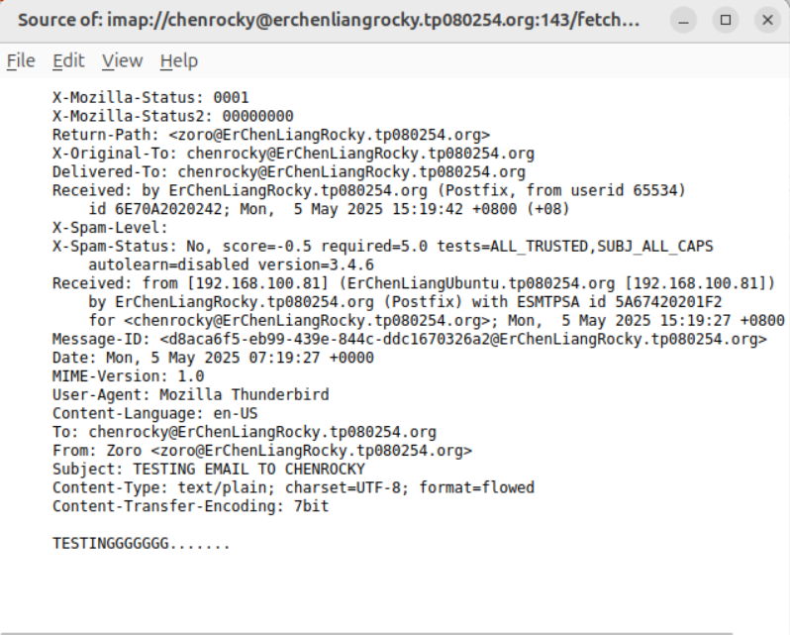

Figure 95

# 8.0 Certificate

This is my Red Hat Academy Completion Course Certificate.

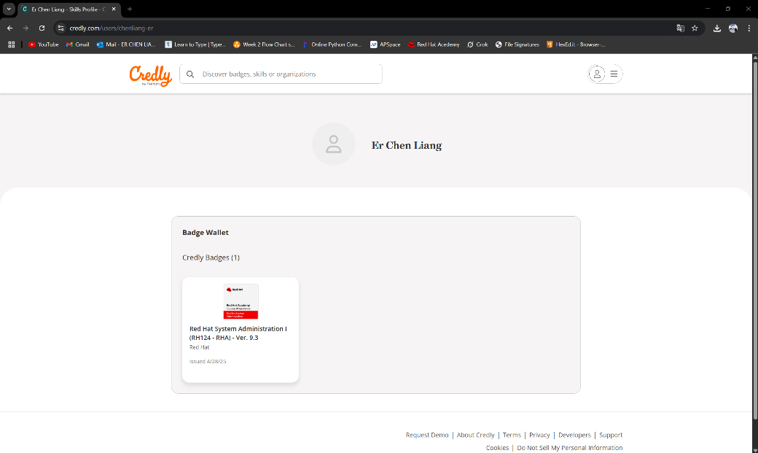

Figure 96

The name show right here is Moe Dreaming that is because that my Red Hat user name is Moe Dreaming.

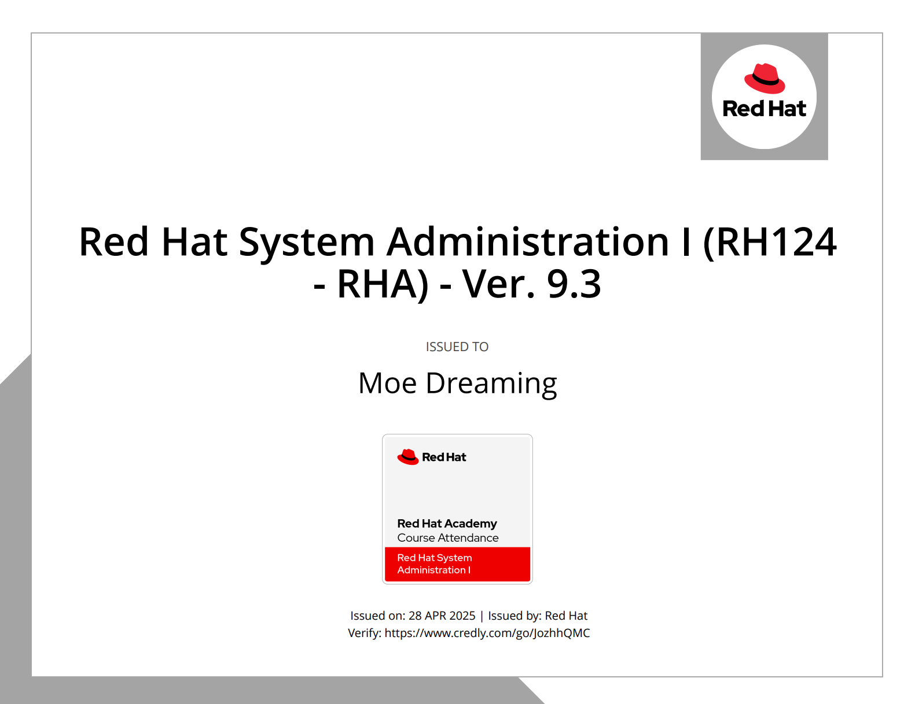

Figure 97

# 9.0 Conclusion

In conclusion, I successfully configured a secure and functional mail system using Rocky Linux as the Mail Server and Ubuntu (Thunderbird) as the Mail Client. Although, I have faced many problems in this assignment but at the end I have deal with them and gain the experience of solving the problems. These challenges and experiences have become the fuel for my learning journey and future development to help me understand the system network administration more.

# 10.0 Reference

*2.2.7.5. Configuring Postfix to use SASL | Red Hat Product Documentation. (n.d.).* [*https://docs.redhat.com/en/documentation/red_hat_enterprise_linux/6/html /security_guide/sect-security_guide-securing_postfixconfiguring_postfix_to_use_sasl#sect-Security_Guide-Securing_PostfixConfiguring_Postfix_to_Use_SASL*](https://docs.redhat.com/en/documentation/red_hat_enterprise_linux/6/html%20/security_guide/sect-security_guide-securing_postfixconfiguring_postfix_to_use_sasl%23sect-Security_Guide-Securing_PostfixConfiguring_Postfix_to_Use_SASL)

NB Tech Support. (2021, August 13). Linux Postfix Mail Server | Dovecot Email Server install & Configure easy Steps [Video]. YouTube. <https://www.youtube.com/watch?v=kdcUfw5vJKY>

Chapter 15. Mail Servers | Red Hat Product Documentation. (n.d.). [https://docs.redhat.com/en/documentation/red_hat_enterprise_linux/7/html /system_administrators_guide/ch-mail_servers#s3-mail-server-dovecot](https://docs.redhat.com/en/documentation/red_hat_enterprise_linux/7/html%20/system_administrators_guide/ch-mail_servers%23s3-mail-server-dovecot)

Koromicha. (2024, March 9). Install Thunderbird Mail Client on Rocky Linux - kifarunix.com. kifarunix.com. <https://kifarunix.com/installthunderbird-mail-client-on-rocky-linux/>